The Project Gutenberg EBook of McGuffey's Second Eclectic Reader
by William Holmes McGuffey

This eBook is for the use of anyone anywhere at no cost and with
almost no restrictions whatsoever. You may copy it, give it away or
re-use it under the terms of the Project Gutenberg License included
with this eBook or online at www.gutenberg.net

Title: McGuffey's Second Eclectic Reader

Author: William Holmes McGuffey

Release Date: June 29, 2005 [EBook #14668]

Language: English

Character set encoding: ASCII

*** START OF THIS PROJECT GUTENBERG EBOOK MCGUFFEY'S SECOND ECLECTIC READER ***

Produced by Don Kostuch

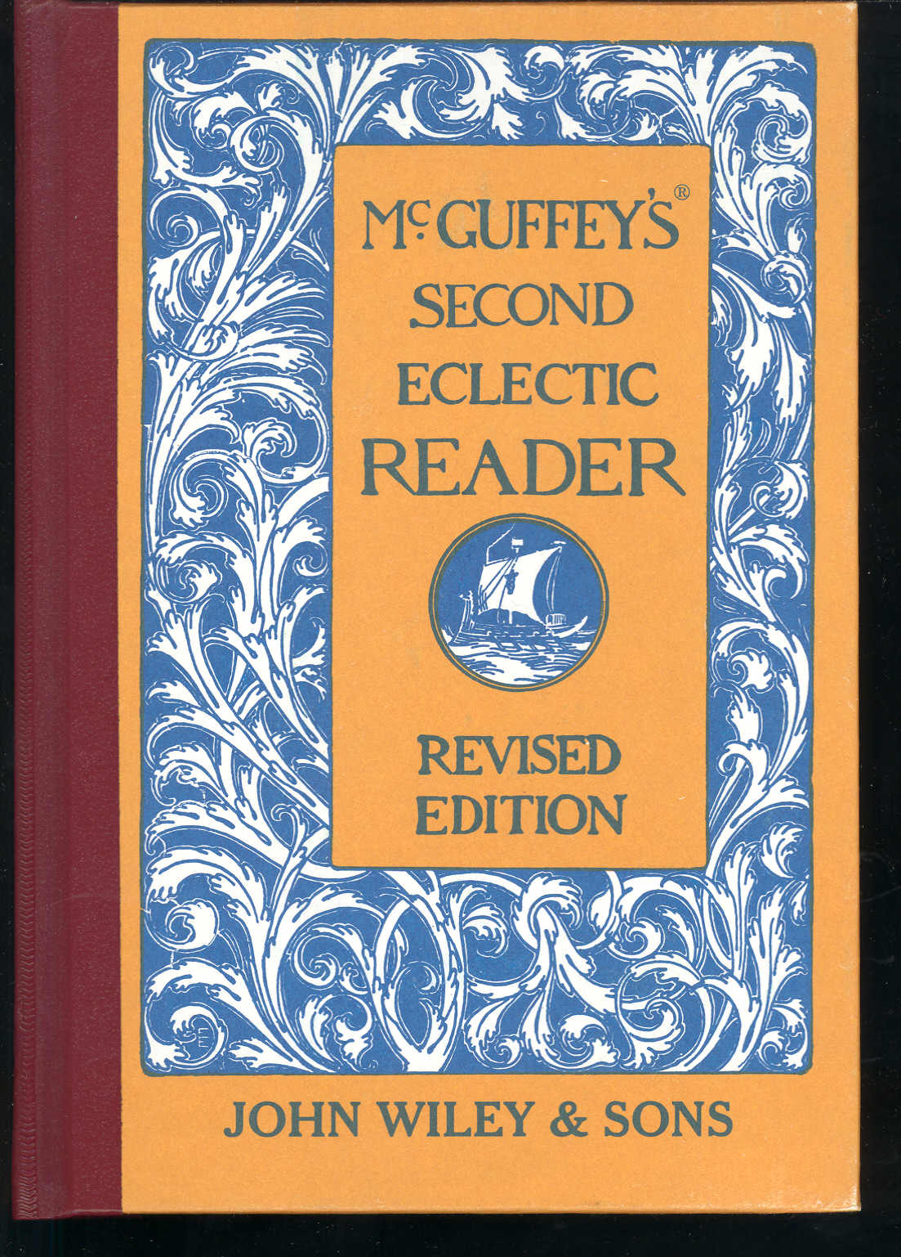

Transcriber's Notes:

Welcome to the schoolroom of 1900. The moral tone is plain. "She is kind to the old blind man."

The exercises are still suitable, and perhaps more helpful than some contemporary alternatives. Much is left to the teacher. Explanations given in the text are enough to get started teaching a child to read and write. Counting in Roman numerals is included as a bonus in the form of lesson numbers.

The "non-ASCI" text remains as images. The "non-ASCI" text is approximated in text boxes to right of the image, as are script images.

The author, not listed in the text is William Holmes McGuffey.

Don Kostuch

ECLECTIC EDUCATIONAL SERIES.

MCGUFFEY'S®

SECOND

ECLECTIC READER.

REVISED EDITION.

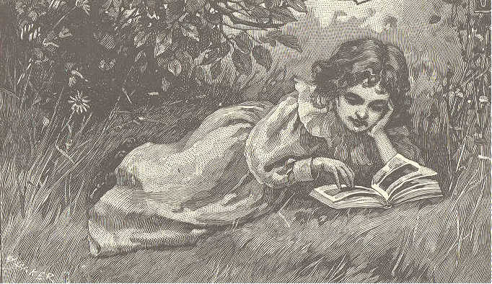
McGuffey Editions and Colophon are Trademarks of
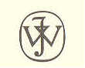
JOHN WILEY & SONS, Inc..
New York - Chichester-Weinheim-Brisbane-Singapore-Toronto

Copyright, 1879, by Van Antwerp, Bragg & Co.
Copyright, 1896, by American Book Company
Copyright, 1907 and 1920, by H. H. Vail.

EP316

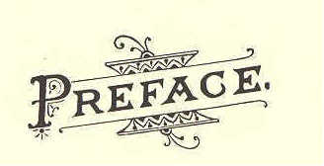

Preface

In this book, as well as in the others of the Revised Series, most of the favorite drill selections, which constituted one of the leading excellences of MCGUFFEY'S READERS, have been retained. New selections have been inserted only when they seemed manifest improvements on those formerly used.
The plan of this Reader is a continuation and extension of that pursued in the First Reader.
If the pupil is not familiar with the diacritical marks, he should be carefully drilled, as suggested on page 7, until the marked letter instantly suggests the correct sound. He is then prepared to study his reading lessons without any assistance from the teacher.
All new words are given at the head of each lesson. When these are mastered, the main difficulties left for the pupil are those of expression. In the latter portion of the book the simpler derivatives,--such as are formed by adding one or two letters,--possessives, plurals, verbal forms, etc.,--are omitted if the primitive word has been given. In this way the pupil is gradually led to the mastery of words as ordinarily printed.
A few of the most usual abbreviations have been introduced,--such as Mr., Mrs., etc. These should be carefully
(iii)
4 PREFACE.

explained, not only as to their meaning and use, but as to the reason for their use.
Great care has been taken to have the illustrations worthy of the reputation MCGUFFEY'S READERS have attained, and some of the foremost designers of this country have contributed to the embellishment of the book.
Many of these pictures will serve admirably for lessons in language, in extension and explanation of the text. The imagination of the artist has, in some cases, filled in details not found in the text.
The thanks of the publishers are due to very many experienced teachers, who have contributed their valuable suggestions.

June, 1879.
Contents 5

INTRODUCTORY MATTER. PAGE.
ARTICULATION 7
PUNCTUATION 9

SELECTIONS IN PROSE AND POETRY.

Lessons.
- Evening at Home 11
- Bubbles 13
- Willie's Letter (Script) 14
- The Little Star 16
- Two Dogs 17
- Afraid in the Dark 19
- Baby Bye 22
- Puss and her Kittens. 24
- Kittie and Mousie 26
- At Work 28
- What a Bird Taught. 29
- Susie Sunbeam 30
- If I were a Sun beam 33
- Henry, the Bootblack 35
- Don't Wake the Baby (Script) 37
- A Kind Brother . 38
- My Good-far-nothing 40
- The Kingbird 41
- Evening Hymn 43
- The Quarrel 44
- The Bee 46
- The Song of the Bee 49
- The Torn Doll 51
- Sheep-shearing 54
- The Clouds . 56
- Patty and the Squirrel 57
- The Sparrow 59
28. Sam and Harry . 61

(v)
6 CONTENTS.

LESSON. Page.
- The Little Rill 63
- The Boat Upset 65
- Mary's Letter (Script) 67
- The Tiger 68
- The Fireside 70
- Birdie's Morning Song 73
- Willie and Bounce 74
- Willie and Bounce 76
- The Kitchen Clock 79
- The New Scales 81
- The Bear and the Children 84
- The Little Harebell (Script) 86
- The Fishhawk 88
- What the Leaf said 90
- The Wind and the Leaves 93
- Mamma's Present 94
- Mary's Story 97
- Ralph Wick 99
- Coasting down the Hill (Script) 102
- The Fox and the Ducks 104
- Pretty is that Pretty does 107
- The Story-teller 109
- The Story-teller 111
- The Owl 113
- The Owl 115
54. Grandfather's Story 117
55. God is Great and Good 119
- A Good Old Man 120
57. The Greedy Girl 124
68. A Place for Everything 126
69. My Mother (Script) 129
- The Broken Window 131
- The Broken Window 133
- Frank and the Hourglass 136
- March 139
- Jenny's Call 140
- Poor Davy 144
- Alice's Supper 148
- A Snowstorm 150
- Bessie 162
- Bessie 156
- Cheerfulness (Script) 158
- Lullaby 160
Second Reader 7

ARTICULATION.

SUGGESTIONS TO TEACHERS.-Thorough and frequent drills on the elementary sounds are useful in correcting vicious habits of pronunciation and in strengthening the vocal organs.
As a rule, only one or two sounds should be employed at one lesson. Care should be taken that the pupils observe and practice these sounds correctly in their reading.

TABLE OF VOCALS.

LONG SOUNDS.
Long Sounds
Sound | as in |  | Sound | as in
a | ate |  | e | err
a | care |  | i | ice
a | arm |  | o | ode
a | last |  | u | use
a | all |  | u | burn
e | eve |  | oo | fool

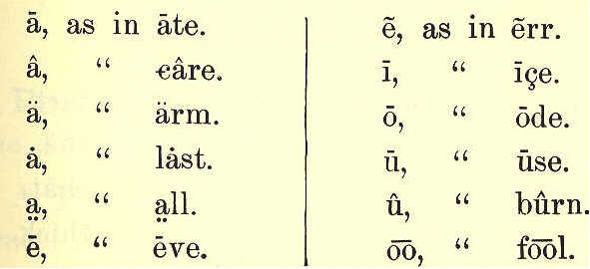

8 ECLECTIC SERIES.
Short Sounds
a | am |  | o | odd
e | end |  | u | up
i | in |  | oo | look
Diphthongs
oi | oil |  | ou | out
oy | boy |  | ow | now

SHORT SOUNDS.
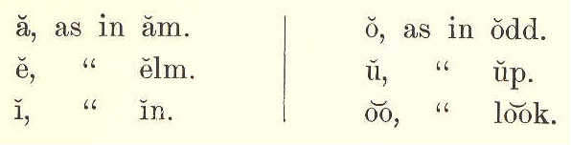

DIPHTHONGS.
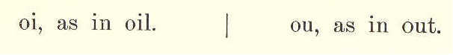
Subvocals
Sound | as in |  | Sound | as in
b | bib |  | v | valve
d | did |  | th | this
g | gig |  | z | zin
j | jug |  | z | azure
n | nine |  | r | rare
m | maim |  | w | we
ng | hang |  | y | yet
l | lull

TABLE OF SUBVOCALS.
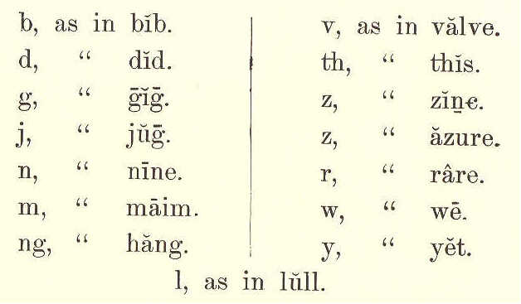

TABLE 0F ASPIRATES.
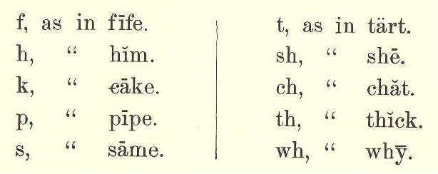
Aspirates
f | fifi |  | t | tat
h | him |  | sh | she
k | kite |  | ch | chat
p | pipe |  | th | thick
s | same |  | wh | why

SECOND READER. 9
Substitutes
Sub | for | as in |  | Sub | for | as in
a | o | what |  | y | I | myth
e | a | there |  | c | k | can
e | a | feint |  | c | a | cite
i | e | police |  | ch | sh | chaise
i | e | sir |  | ch | k | chaos
o | u | son |  | g | j | gem
o | oo | to |  | n | ng | ink
o | oo | wolf |  | s | z | as
o | a | fork |  | s | sh | sure
o | u | work |  | x | gz | exact
u | oo | full |  | gh | f | laugh
u | oo | rude |  | ph | f | phlox
y | i | fly |  | qu | k | pique
qu | kw | quit

TABLE OF SUBSTITUTES.
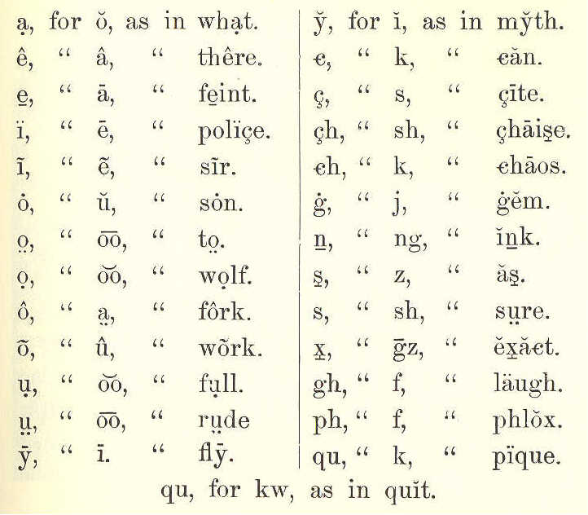

PUNCTUATION.

Punctuation Marks are used to make the sense more clear.
A Period (.) is used at the end of a sen-
tence, and after an abbreviation; as,

James was quite sick. Dr. Jones was called to see him.
10 ECLECTIC SERIES.

An Interrogation Mark (?) is used at the end of a question; as,

Where is John going?

An Exclamation Mark (!) is used after words or sentences expressing some strong feeling; as,

Alas, my noble boy! that thou shouldst die!

The Comma (,), Semicolon (;), and Colon (:) are used to separate the parts of a sentence.

The Hyphen (-) is used to join the parts of a compound word; as, text-book: it is also used at the end of a line in print or script, when a word is divided; as in the word "sentence," near the bottom of page 9.

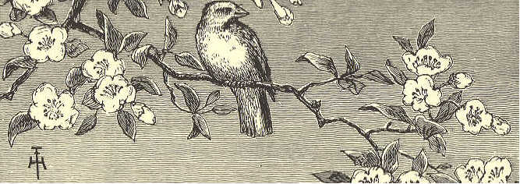
SECOND READER. 11

MCGUFFEY'S
SECOND READER.

LESSON I.
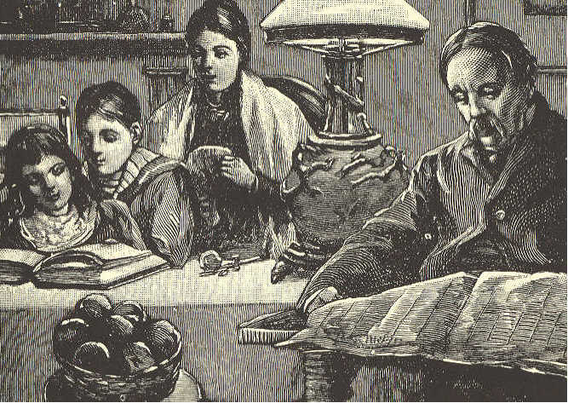
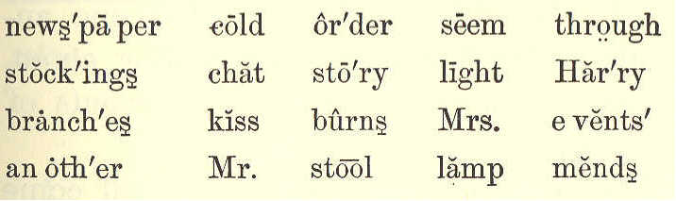
news'paper cold or'der seem through
stock'ings chat sto'ry light Har'ry
branch'es kiss burns Mrs. e vents'
an oth'er Mr. stool lamp mends

EVENING AT HOME.

1. It is winter. The cold wind whistles through the branches of the trees.

(11)
12 ECLECTIC SERIES.

2. Mr. Brown has done his day's work, and his children, Harry and Kate, have come home from school. They learned their lessons well to-day, and both feel happy
3. Tea is over. Mrs. Brown has put the little sitting room in order. The fire burns brightly. One lamp gives light enough for all. On the stool is a basket of fine apples. They seem to say, "Won't you have one?"
4. Harry and Kate read a story in a new book. The father reads his newspaper, and the mother mends Harry's stockings.
5. By and by, they will tell one another what they have been reading about, and will have a chat over the events of the day.
6. Harry and Kate's bedtime will come first. I think I see them kiss their dear father and mother a sweet good night.
7. Do you not wish that every boy and girl could have a home like this?
SECOND READER. 13

LESSON II.

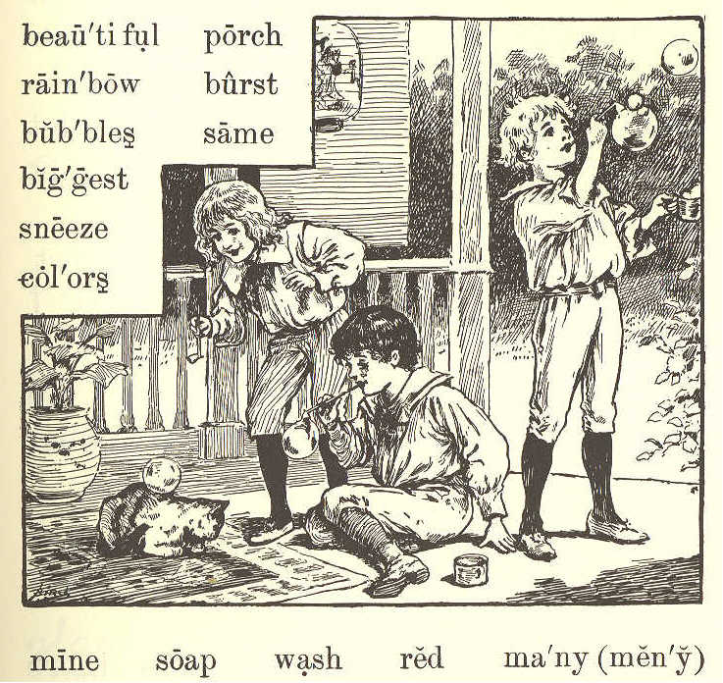
beau'ti ful porch
rain'bow burst
bub'bling same
biggest
sneeze
col'ors
main soap wash red ma'ny (men'y)

BUBBLES.
1. The boys have come out on the porch to blow bubbles. The old cat is asleep on the mat by the door.
2. "Ha! ha!" laughs Robert, as a bubble comes down softly on the old cat's back, and does not burst.
14 ECLECTIC SERIES.

3. Willie tries to make his bubble do the same. This time it comes down on the cat's face, and makes her sneeze.
4. "She would rather wash her face without soap," says Harry. "Now let us see who can make the biggest bubble."
5. "Mine is the biggest," says Robert. "See how high it floats in the air! I can see--ah! it has burst."
6. "I can see the house and the trees and the sky in mine," says Willie; "and such beautiful colors."
- "How many, Willie?"
8. "Red, one; blue, two; there--they are all out. Let us try again."
9. "I know how many colors there are," says Harry. "Just as many as there are in the rainbow."
10. "Do you know how many that is?"

LESSON III.
rub'ber gun par'lor street
num'ber ten o'clock' shoot
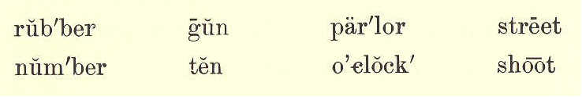

SECOND READER. 15

WILLIE'S LETTER.
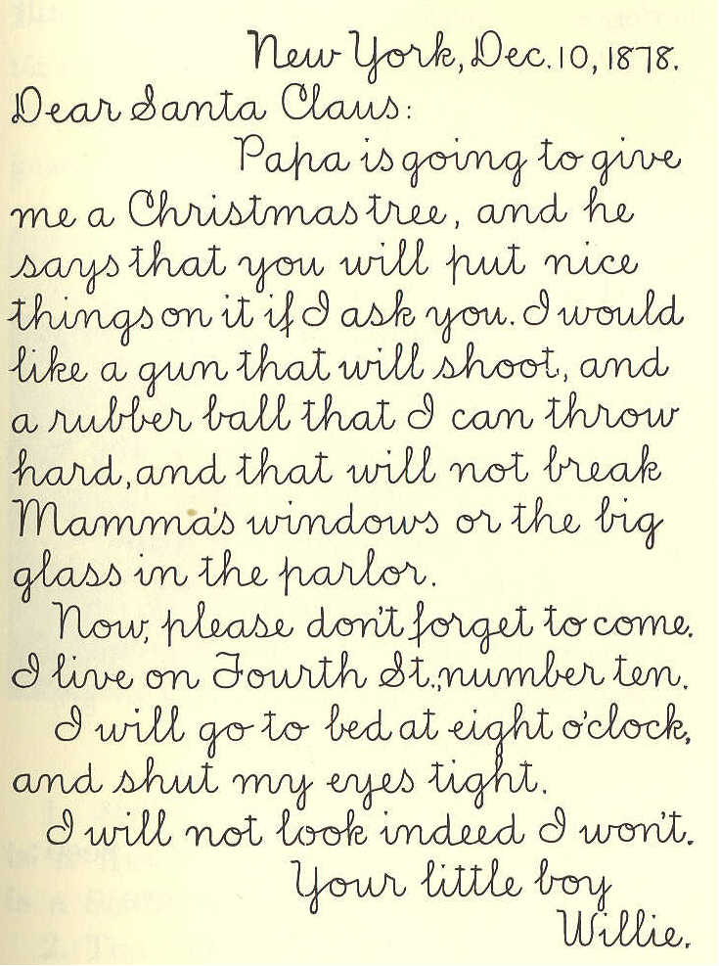
New York, Dec. 10, 1878.
Dear Santa Claus:
Papa is going to give
me a Christmas tree, and he
says that you will put nice
things on it if I ask you. I would
like a gun that will shoot, and
a rubber ball that I can throw
hard, and that will not break
Mamma's windows or the big
glass in the parlor.
Now, please don't forget to come.
I live on Fourth St., number ten.
I will go to bed at eight o'clock,
and shut my eyes tight.
I will not look, indeed I won't.
Your little boy,
Willie.

16 ECLECTIC SERIES

LESSON IV.
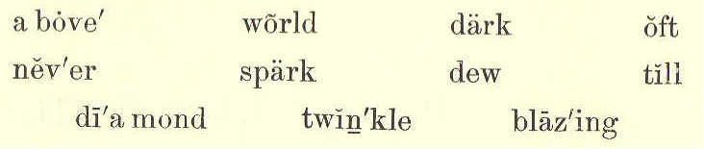
a bove' world dark oft
nev'er spark dew till
di'a mond twin'kle blaz'ing

The Little Star

1. Twinkle, twinkle, little star;
How I wonder what you are,
Up above the world so high,
Like a diamond in the sky!

2. When the blazing sun is set,
And the grass with dew is wet,
Then you show your little light;
Twinkle, twinkle, all the night.

3. Then, if I wore in the dark,
I would thank you for your spark.
I could not see which way to go,
If you did not twinkle so.

4. And when I am sound asleep,
Oft you through my window peep;
For you never shut your eye,
Till the sun is in the sky.
SECOND READER. 17

LESSON V.
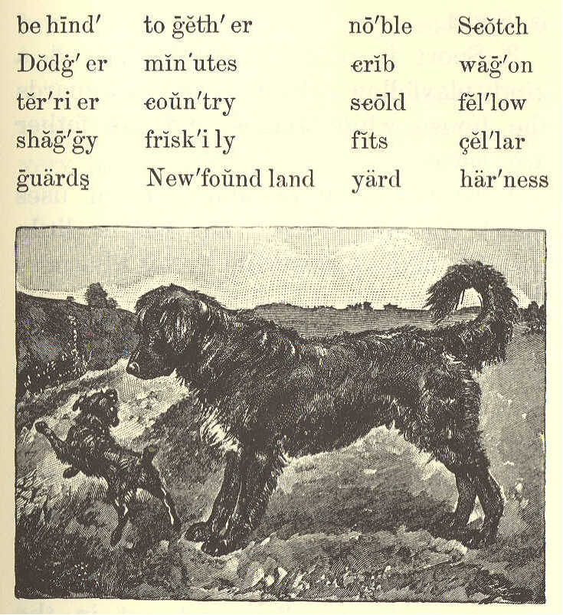
be hind' to geth'er nob'le Scotch
Dodg'er min'utes crib wag'on
ter'ri er coun'try scold fel'low
shag'gy frisk'i ly fits cel'lar
guards New'found land yard har'ness

TWO DOGS.

1. James White has two dogs. One is a Newfoundland dog, and the other is a Scotch terrier.
2. The Newfoundland is a large, noble

2,2.
18 ECLECTIC SERIES.

fellow. He is black, with a white spot, and with long, shaggy hair. His name is Sport.
3. Sport is a good watchdog, and a kind playfellow. Every night he guards the house while James and his father are asleep.
4. In the daytime, James often uses Sport for his horse. He has a little wagon, and a set of small harness which just fits the dog.
5. He hitches Sport to this wagon, and drives over the country. In this way, he can go almost as fast as his father with the old family horse.
6. The name of James's Scotch terrier is Dodger. He is called Dodger because he jumps about so friskily. He is up on a chair, under the table, behind the door, down cellar, and out in the yard,--all in a minute.
7. Dodger has very bright eyes, and he does many funny things. He likes to put his paws up on the crib, and watch the baby.

SECOND READER. 19

8. The other day he took baby's red stocking, and had great fun with it; but he spoiled it in his play, and James had to scold him.
9. Everyone likes to see James White with his two dogs. They always seem very happy together.

LESSON VI.
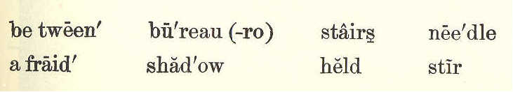
bet ween' bu'reau (-ro) stairs nee'dle
a fraid' shad'ow held stir

AFRAID IN THE DARK.

1. "Willie, will you run upstairs, and get my needle book from the bureau?"
2. But Willie did not stir. "Willie!" said mamma. She thought he had not heard.
3. "I'm afraid," said Willie.
4. "Afraid of what?"
5. "It's dark up there."
6. "What is the dark?" asked mamma. "See! It is nothing but a shadow."
20 ECLECTIC SERIES.

And she held her hand between the lamp and the workbasket on the table.

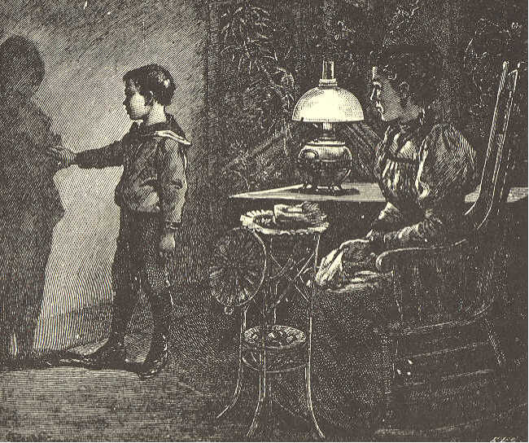

7. "Now it is dark in the basket; but as soon as I take my hand away, it is light."
8. "Come and stand between the lamp and the wall, Willie. See! There is your shadow on the wall. Can your shadow hurt you?"
9. "Oh no, mamma! I am sure it can not hurt me."
10. "Well, the dark is only a big shadow over everything."
SECOND READER. 21

11. "What makes the big shadow, mamma?"
12. "I will tell you all about that, Willie, when you are a little older. But now, I wish you would find me a brave boy who is not afraid of shadows, to run upstairs and get my needlebook."
13. "I am bravo, mamma. I will go. --Here it is."
14. "Thank you, my brave little man. You see the dark didn't hurt you."

SLATE WORK.

Beautiful faces are they that wear
The light of a pleasant spirit there;
Beautiful hands are they that do
Deeds that are noble good and true;
Beautiful feet are they that go
Swiftly to lighten another's woe.

22 ECLECTIC SERIES

LESSON VII.
spi'ders tick'ling
stay neck
nose se'cret
crawls legs
beck ope
goes toes
speck choose
dot nod
shoes spread be lieve' six
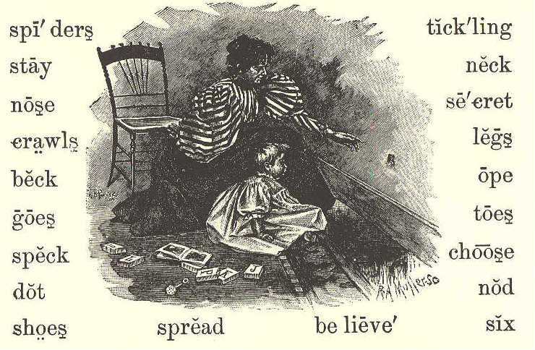

BABY BYE.

1. Baby Bye,
Here's a fly;
We will watch him, you and I.
How he crawls
Up the walls,
Yet he never falls!
I believe with six such legs
You and I could walk on eggs.
There he goes
On his toes,
Tickling Baby's nose.
SECOND READER. 23

- Spots of red
Dot his head;
Rainbows on his back are spread;
That small speck
Is his neck;
See him nod and beck!
I can show you, if you choose,
Where to look to find his shoes,
Three small pairs,
Made of hairs;
These he always wears.

- Flies can see
More than we;
So how bright their eyes must be!
Little fly,
Ope your eye;
Spiders are near by.
For a secret I can tell,
Spiders never use flies well;
Then away,
Do not stay.
Little fly, good day.
24 ECLECTIC SERIES.

LESSON VIII.

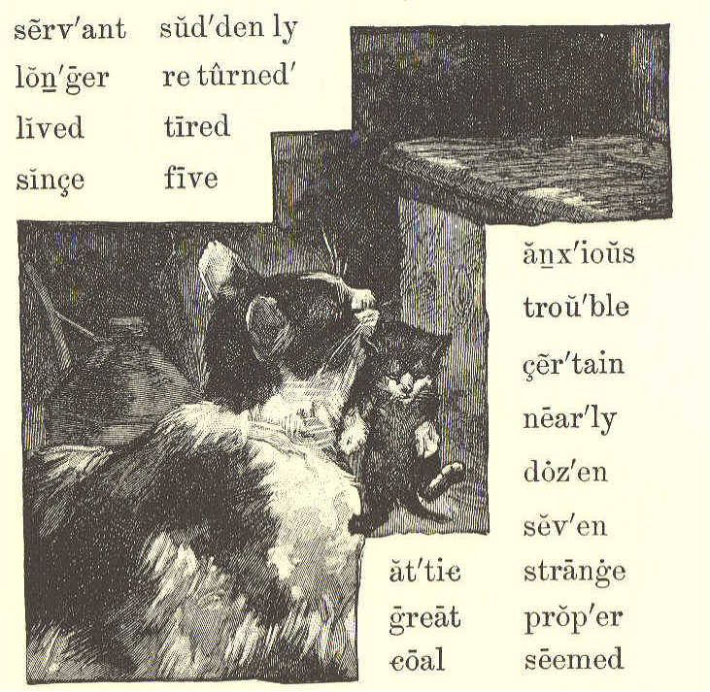
serv'ant sud'den ly
lon'ger re turned'
lived tired
since five
anx'ious
trou'ble
cer'tain
nea'ly
doz'en
sev'en
at'tic strange
great prop'er
coal seemed

PUSS AND HER KITTENS.

1. Puss, with her three kittens, had lived in the coal cellar; but one day she thought she would carry them to the attic.
2. The servant thought that was
SECOND READER. 25

not the proper place for them; so she carried them back to the cellar.
3. Puss was certain that she wanted them in the attic; so she carried them there again and again, five, six, seven, --yes, a dozen times; for each time the servant took them back to the cellar.
4. Poor puss was nearly tired out, and could carry them no longer.
5. Suddenly she went away. Where do you think she went?
6. She was gone a long time. When she returned, she had a strange cat with her that we had never seen before.
7. She seemed to tell him all about her great trouble, and he listened to her story.
8. Then the strange cat took the little kittens, one by one, and carried them to the attic. After this he went away, and we have never seen him since.
9. The servant then left the kittens in the attic, for she saw how anxious puss was to have them stay there.
26 ECLECTIC SERIES.

10. Was not the strange cat kind to puss? This lesson should teach children to be ever ready to help one another.

LESSON IX.

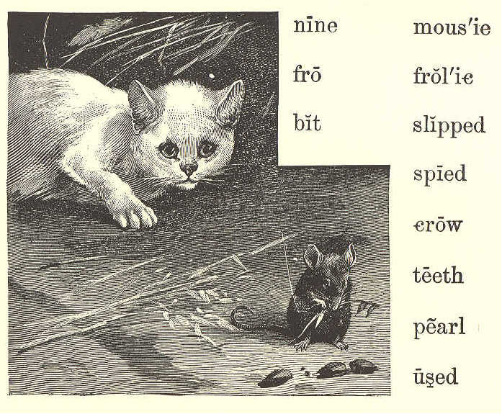
nine mous'ie
fro frol'ic
bit slipped
spied
crow
teeth
pearl
used

KITTY AND MOUSIE.

1. Once there was a little kitty,
White as the snow;
In a barn he used to frolic,
Long time ago.
SECOND READER. 27

2. In the barn a little mousie
Ran to and fro;
For she heard the little kitty,
Long time ago.

3. Two black eyes had little kitty,
Black as a crow;
And they spied the little mousie,
Long time ago.

4. Four soft paws had little kitty,
Paws soft as snow;
And they caught the little mousie,
Long time ago.

5. Nine pearl teeth had little kitty,
All in a row;
And they bit the little mousie,
Long time ago.

6. When the teeth bit little mousie,
Mousie cried out "Oh!"
But she slipped away from kitty,
Long time ago.
28 ECLECTIC SERIES

LESSON X.

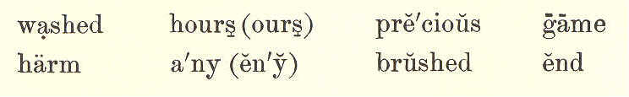
washed hours(ours) pre'cious game
harm a'ny (en'y) brushed end

AT WORK.

1. A little play does not harm any one, but does much good. After play, we should be glad to work.
2. I knew a boy who liked a good game very much. He could run, swim, jump, and play ball; and was always merry when out of school.
3. But he knew that time is not all for play; that our minutes, hours, and days are very precious.
4. At the end of his play, he would go home. After he had washed his face and hands, and brushed his hair, he would help his mother, or read in his book, or write upon his slate.
5. He used to say, "One thing at a time." When he had done with work, he would play; but he did not try to play and to work at the same time.
SECOND READER. 29

LESSON XI.

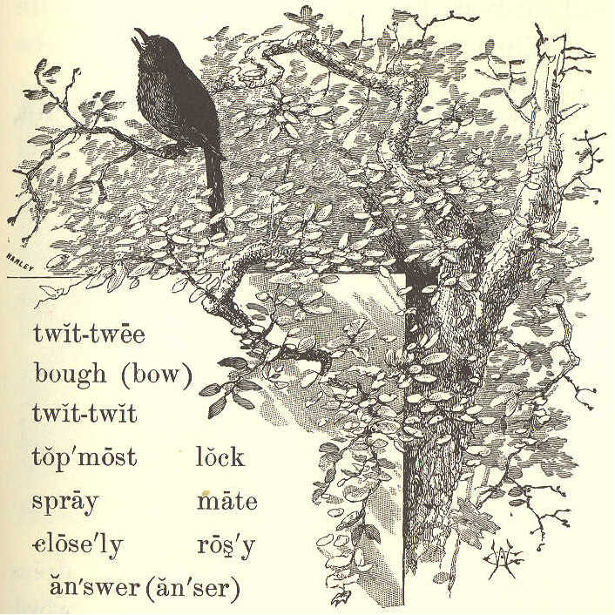
twit-twee
bough (bow)
twit-twit
top'most lock
spray mate
close'ly ros'y
an'swer (an'ser)

WHAT A BIRD TAUGHT.

1. Why do you come to my apple tree,
Little bird so gray?
Twit-twit, twit-twit, twit-twit-twee!
That was all he would say.
30 ECLECTIC SERIES.

2. Why do you lock your rosy feet
So closely round the spray?
Twit-twit, twit-twit, twit-tweet!
That was all he would say.

3. Why on the topmost bough do you get,
Little bird so gray?
Twit-twit-twee! twit-twit-twit!
That was all he would say.

4. Where is your mate? come, answer me,
Little bird so gray.
Twit-twit-twit! twit-twit-twee!
That was all he would say.
Alice Cary.

LESSON XII.
bright'ness pleas'ant learned dress
play'mates un kind' rag'ged word
ques'tions smil'ing crowed child
Sun'beam cheered Sus'ie gave
glad'ness un less' name gate
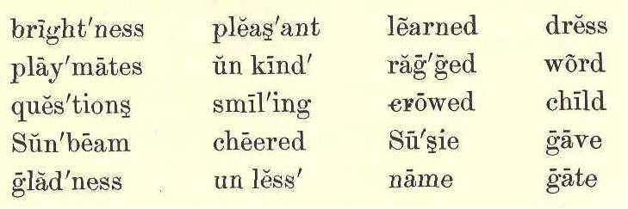

SUSIE SUNBEAM.

1. Susie Sunbeam was not her real name; that was Susan Brown. But every
SECOND READER. 31

one called her Susie Sunbeam, because she had such a sweet, smiling face, and always brought brightness with her when she came.

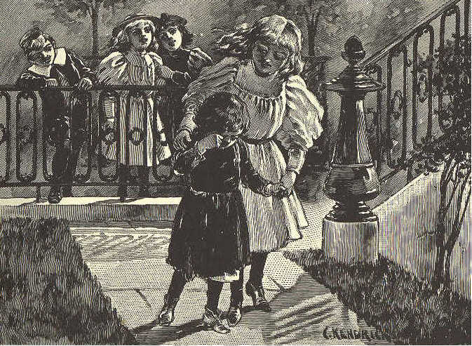

2. Her grandfather first gave her this name, and it seemed to fit the little girl so nicely that soon it took the place of her own.
3. Even when a baby, Susie laughed and crowed from morning till night. No one ever heard her cry unless she was sick or hurt.
4. When she had learned to walk,
32 ECLECTIC SERIES.

she loved to go about the house and get things for her mother, and in this way save her as many steps as she could.
5. She would sit by her mother's side for an hour at a time, and ask her ever so many questions, or she would take her new book and read.
6. Susie was always pleasant in her play with other children. She never used an unkind word, but tried to do whatever would please her playmates best.
7. One day, a poor little girl with a very ragged dress was going by and Susie heard some children teasing her and making fun of her.
8. She at once ran out to the gate, and asked the poor little girl to come in. "What are you crying for?" Susie asked.
9. "Because they all laugh at me," she said.
10. Then Susie took the little girl into the house. She cheered her up with
SECOND READER. 33

kind words, and gave her a nice dress and a pair of shoes.
11. This brought real joy and gladness to the poor child, and she, too, thought that Susie was rightly called Sunbeam.

LESSON XIII.
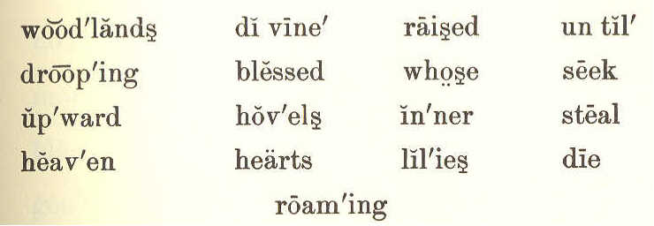
wood'lands di vine' raised un til'
droop'ing blessed whose seek
up'ward hov'els in'ner steal
heav'en hearts lil'ies die
roam'ing

IF I WERE A SUNBEAM.

1. "If I were a sunbeam,
I know what I'd do;
I would seek white lilies,
Roaming woodlands through.
I would steal among them,
Softest light I'd shed,
Until every lily
Raised its drooping head.
34 ECLECTIC SERIES.

2. "If I were a sunbeam,
I know where I'd go;
Into lowly hovels,
Dark with want and woe:
Till sad hearts looked upward,
I would shine and shine;
Then they'd think of heaven,
Their sweet home and mine."

3. Are you not a sunbeam,
Child, whose life is glad
With an inner brightness
Sunshine never had?
Oh, as God has blessed you,
Scatter light divine!
For there is no sunbeam
But must die or shine.

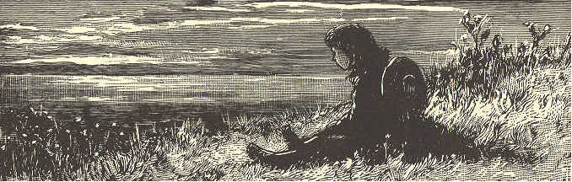
SECOND READER. 35

LESSON XIV.

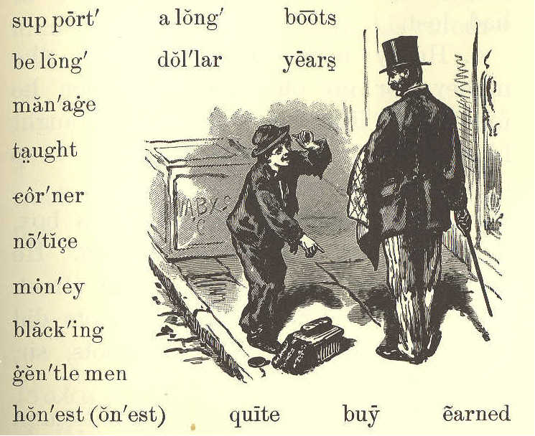
sup port' a long' boots
be long' dol'lar years
man'age
taught
cor'ner
no'tice
mon'ey
black'ing
gen'tle men
hon'est (on'est) quite buy earned

HENRY, THE BOOTBLACK.

1. Henry was a kind, good boy. His father was dead, and his mother was very poor. He had a little sister about two years old.

2. He wanted to help his mother, for she could not always earn enough to buy food for her little family.
36 ECLECTIC SERIES.

3. One day, a man gave him a dollar for finding a pocketbook which he had lost.
4. Henry might have kept all the money, for no one saw him when he found it. But his mother had taught him to be honest, and never to keep what did not belong, to him.
5. With the dollar he bought a box, three brushes, and some blacking. He then went to the corner of the street, and said to every one whose boots did not look nice, "Black your boots, sir, please? "
6. He was so polite that gentlemen soon began to notice him, and to let him black their boots. The first day he brought home fifty cents, which he gave to his mother to buy food with.
7. When he gave her the money, she said, as she dropped a tear of joy, "You are a dear, good boy, Henry. I did not know how I could earn enough to buy bread with, but now I think we can manage to get along quite well,"

SECOND READER. 37

8. Henry worked all the day, and went to school in the evening. He earned almost enough to support his mother and his little sister.
LESSON XV.
tread whis'per soft'ly
talk cheer ful' care'ful
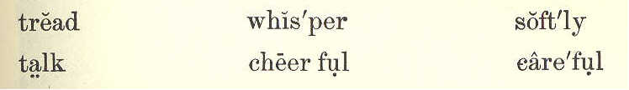

DON'T WAKE THE BABY.

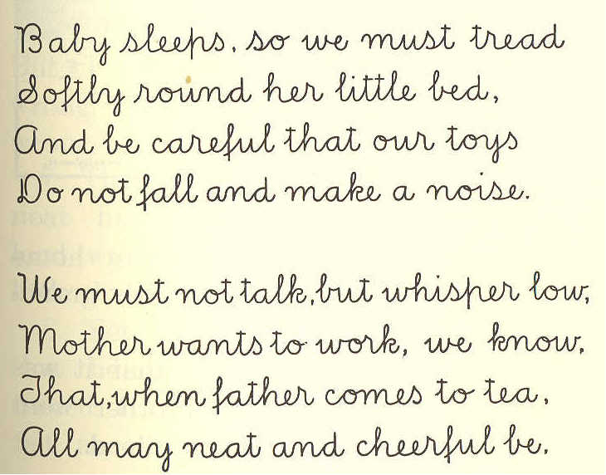
Baby sleeps, so we must tread
Softly round her little bed,
And be careful that our toys
Don not fall and make a noise.

We must not talk, but whisper low,
Mother wants to work, we know,
That, when father comes to tea,
All may neat and cheerful be.

38 ECLECTIC SERIES.

LESSON XVI.
full load heav'y mid'dle heav'i er
slip wrong han'dle broth'er de ceived'
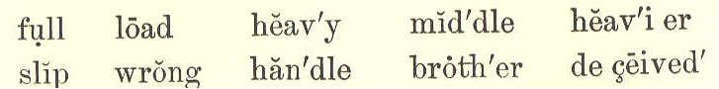

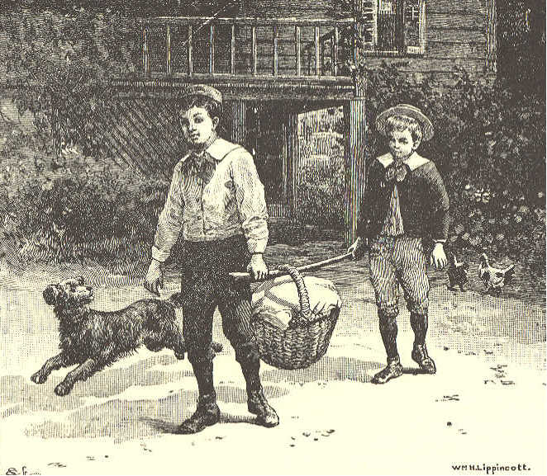

A KIND BROTHER.

1. A boy was once sent from home to take a basket of things to his grandmother.
2. The basket was so full that it was very heavy. So his little brother went with him, to help carry the load.
SECOND READER. 39

3. They put a pole under the handle of the basket, and each then took hold of an end of the pole. In this way they could carry the basket very nicely.
4. Now the older boy thought, "My brother Tom does not know about this pole.
5. "If I slip the basket near him, his side will be heavy, and mine light; but if the basket is in the middle of the pole, it will be as heavy for me as it is for him.
6. "Tom does not know this as I do. But I will not do it. It would be wrong, and I will not do what is wrong."
7. Then he slipped the basket quite near his own end of the pole. His load was now heavier than that of his little brother.
8. Yet he was happy; for he felt that he had done right. Had he deceived his brother, he would not have felt at all happy.
40 ECLECTIC SERIES.

LESSON XVII.

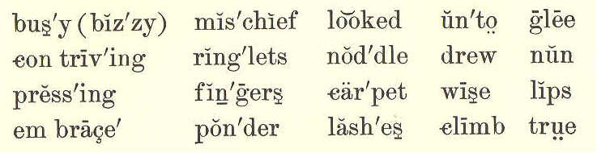
bus'y (biz'zy) mis'chief looked un'to glee
con triv'ing ring'lets nod'dle drew nun
press'ing fin'gers car'pet wise lips
em brace' pon'der lash'es climb true

MY GOOD-FOR-NOTHING.

1.
"What are you good for, my brave little man?
Answer that question for me, if you can,--
You, with your fingers as white as a nun,--
You, with your ringlets as bright as the sun.
All the day long, with your busy contriving,
Into all mischief and fun you are driving;
See if your wise little noddle can tell
What you are good for. Now ponder it well."

2.
Over the carpet the dear little feet
Came with a patter to climb on my seat;
Two merry eyes, full of frolic and glee,
Under their lashes looked up unto me;
Two little hands pressing soft on my face,
Drew me down close in a loving embrace;
Two rosy lips gave the answer so true,
"Good to love you, mamma, good to love you."
Emily Huntington Miller.
SECOND READER. 41

LESSON XVIII.
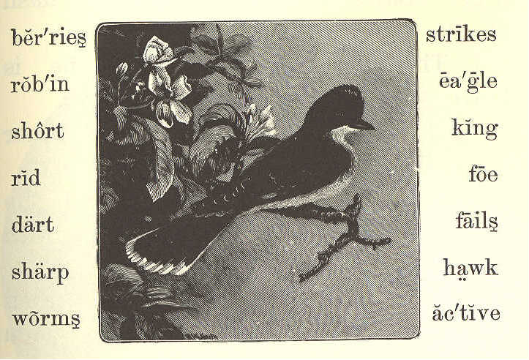
ber'ries strikes
rob'in ea'gle
short king
rid foe
dart fails
sharp hawk
worms ac'tive

THE KINGBIRD.

1. The kingbird is not bigger than a robin.
2. He eats flies, and worms, and bugs, and berries.
3. He builds his nest in a tree, near some house.
4. When there are young ones in the nest, he sits on the top of a tree near them.
5. He watches to see that no bird comes to hurt them or their mother.
42 ECLECTIC SERIES.

6. If a hawk, a crow, or even an eagle comes near, he makes a dash at it.
7. Though he is so small, he is brave, and he is also very active.
8. He never fails to drive off other birds from his nest.
9. He flies around and around the eagle, and suddenly strikes him with his sharp bill.
10. He strikes at his eye, and then darts away before the eagle can catch him.
11. Or he strikes from behind, and is off again before the eagle can turn round.
12. In a short time, the great eagle is tired of such hard blows, and flies away. He is very glad to get rid of his foe.
13. Is not the little fellow a brave bird?
14. Because he can drive off all other birds, he is called the KINGBIRD.
SECOND READER. 43

LESSON XIX.
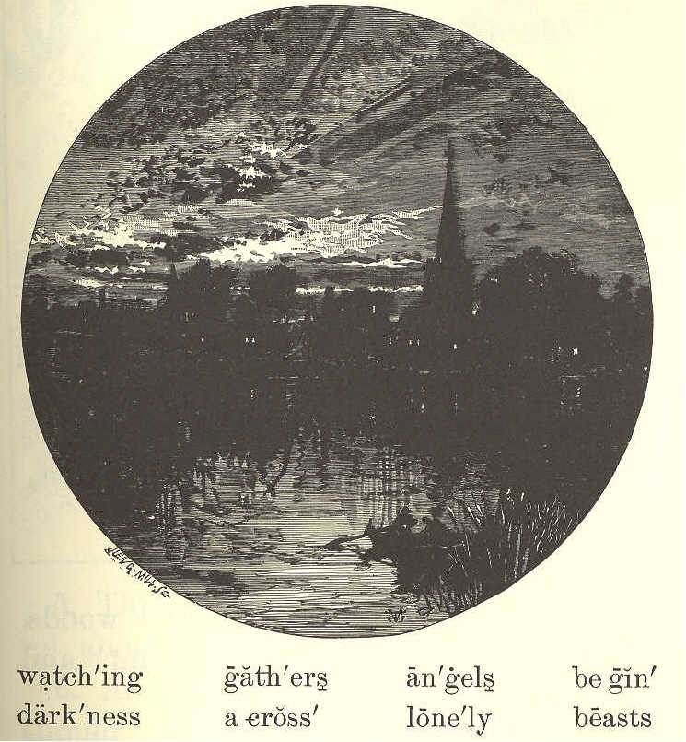
watch'ing gath'ers an'gels be gin'
dark'ness a cross' lone'ly beasts

EVENING HYMN.

1. Now the day is over,
Night is drawing nigh,
Shadows of the evening
Steal across the sky.
44 ECLECTIC SERIES.

2. Now the darkness gathers,
Stars begin to peep;
Birds, and beasts, and flowers
Soon will be asleep.

3. Through the lonely darkness,
May the angels spread
Their white wings above me,
Watching round my bed.

LESSON XX.
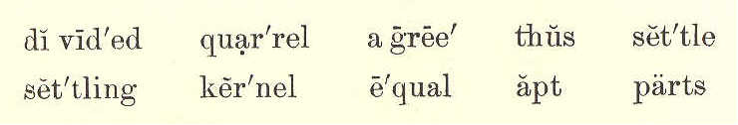
di vid'ed quar'rel a gree' thus set'tle
set'tling ker'nel e'qual apt parts

THE QUARREL.
1. Under a great tree in the woods, two boys saw a fine, large nut, and both ran to get it.
2. James got to it first, and picked it up.
3. "It is mine," said John, "for I was the first to see it."
4. "No, it is mine" said James, "for I was the first to pick it up."
SECOND READER. 45

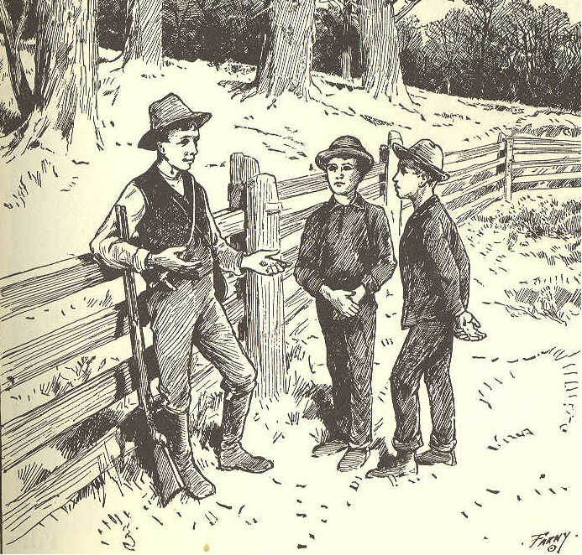

5. Thus, they at once began to quarrel about the nut.
6. As they could not agree whose it should be, they called an older boy, and asked him.
7. The older boy said, "I will settle this quarrel."
8. He took the nut, and broke the shell. He then took out the kernel,
46 ECLECTIC SERIES.

and divided the shell into two parts, as nearly equal as he could.
9. "This half of the shell," said he, "belongs to the boy who first saw the nut.
10. "And this half belongs to the boy who picked it up.
11. "The kernel of the nut, I shall keep as my pay for settling the quarrel.
12. "This is the way," said he, laughing, "in which quarrels are very apt to end."

LESSON XXI.
crea'tures drones in'side hive i'dle
de fense' driv'en killed cells size
work'ers queen stings shape wax
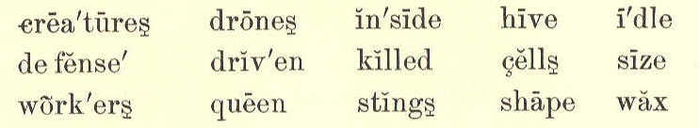

THE BEE.
1. Bees live in a house that is called a hive. They are of three kinds,--workers, drones, and queens.
2. Only one queen can live in each hive. If she is lost or dead, the other bees will stop their work.
SECOND READER. 47

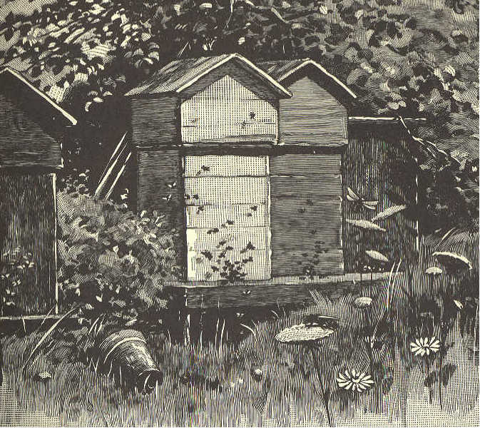

3. They are very wise and busy little creatures. They all join together to build cells of wax for their honey.
4. Each bee takes its proper place, and does its own work. Some go out and gather honey from the flowers; others stay at home and work inside the hive.
5. The cells which they build, are all of one shape and size, and no room is left between them.
48 ECLECTIC SERIES.

6. The cells are not round, but have six sides.
7. Did you ever look into a glass hive to see the bees while at work? It is pleasant to see how busy they always are.
8. But the drones do not work. Before winter comes, all the drones are driven from the hive or killed, that they may not eat the honey which they did not gather.
9. It is not quite safe for children to handle bees. They have sharp stings that they know well how to use in their defense.

SLATE WORK.
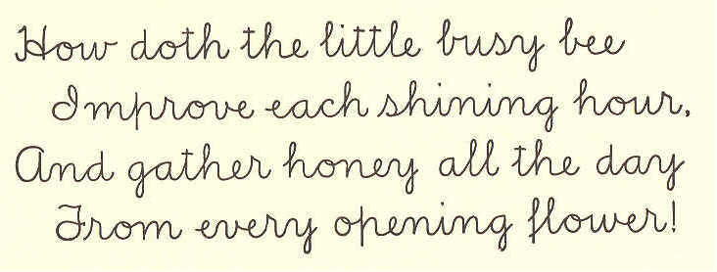
How doth the little busy bee
Improve each shining hour.
And gather honey all the day
From every opening flower!

SECOND READER. 49

LESSON XXII.

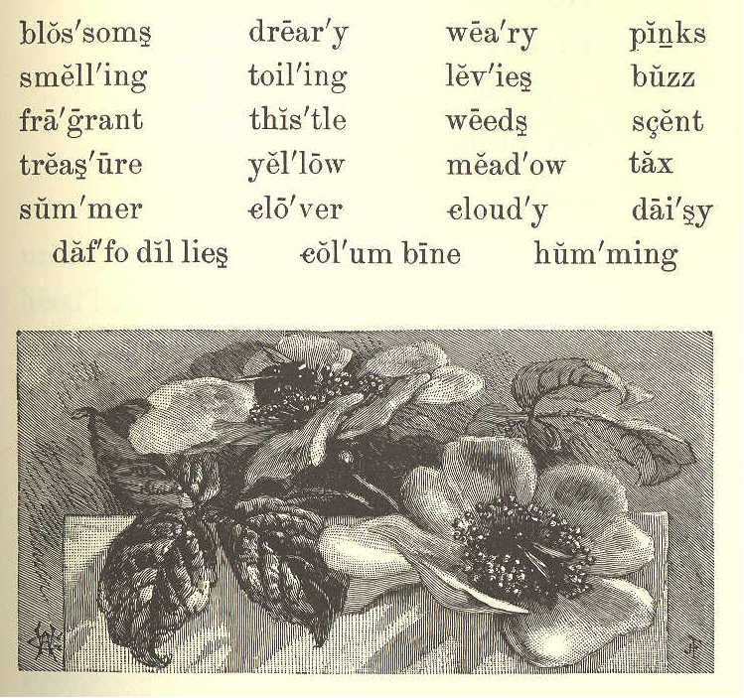
blos'soms drear'y wea'ry pinks
smell'ing toil'ing lev'ies buzz
fra'grant this'tle weeds scent
treas'ure yel'low mead'ow tax
sum'mer clo'ver cloud'y dai'sy
daf'fo dil lies columbine humming

THE SONG OF THE BEE.

1. Buzz! buzz! buzz!
This is the song of the bee.
His legs are of yellow;
A jolly, good fellow,
And yet a great worker is he.
50 ECLECTIC SERIES.

2. In days that are sunny
He's getting his honey;
In days that are cloudy
He's making his wax:
On pinks and on lilies,
And gay daffodillies,
And columbine blossoms,
He levies a tax!

- Buzz! buzz! buzz!
The sweet-smelling clover,
He, humming, hangs over;
The scent of the roses
Makes fragrant his wings:
He never gets lazy;
From thistle and daisy,
And weeds of the meadow,
Some treasure he brings.

4. Buzz! buzz! buzz!
From morning's first light
Till the coming of night,
He's singing and toiling
The summer day through.
SECOND READER. 51

Oh! we may get weary,
And think work is dreary;
'Tis harder by far
To have nothing to do.
Marian Douglas.

LESSON XXIII.

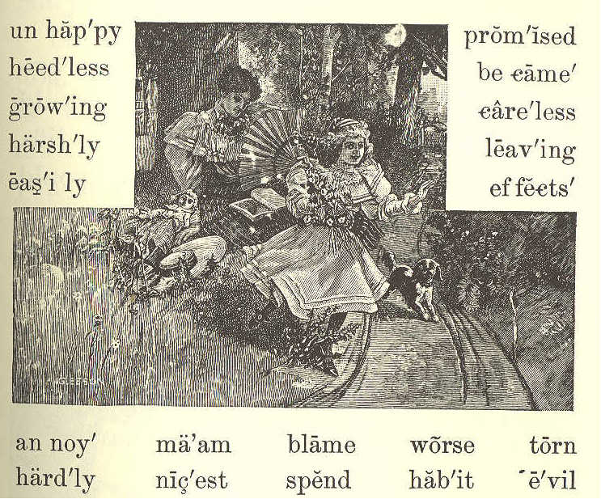
un hap'py prom'ised
heed'less be came'
grow'ing care'less
harsh'ly leav'ing
eas'i ly ef fects'

an noy' ma'am blame worse torn
hard'ly nic'est spend hab'it e'vil

THE TORN DOLL.

1. Mary Armstrong was a pretty little girl, but she was heedless about some things.
52 ECLECTIC SERIES.

2. Her way of leaving her books and playthings just where she had used them last, gave her mother much trouble in picking them up and putting them in their proper places.
3. She had often told Mary the evil effects of being so careless. Her books became spoiled, and her toys broken.
4. But worse than this was the growing habit of carelessness, which would be of great harm to her all her life. It would make her unhappy, and would annoy her friends.
5. One day Mary and her mother went out into their pleasant yard, to spend an hour in the open air. Mrs. Armstrong took her work with her.
6. Mary ran about and played with Dash, her pet dog, and was having a happy time.
7. But in a corner of the yard she found her nicest doll all torn and broken, and its dress covered with mud.
8. She knew, at once, that Dash had done this, and she scolded him harshly.
SECOND READER. 53

9. Carrying the broken doll to her mamma. she showed it to her, and could hardly keep from crying.
10. Mrs. Armstrong asked Mary if she had not left the doll on the porch where Dash could easily get it; and Mary had to answer, "Yes, ma'am."
11. "Then you must not blame the dog, Mary, for he does not know it is wrong for him to play with your doll. I hope this will be a lesson to you hereafter, to put your things away when you are through playing."
12. "I will try," said Mary. And her mother promised to mend the doll as well as she could.

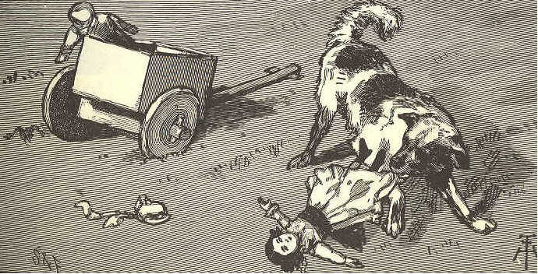
54 ECLECTIC SERIES

LESSON XXIV.

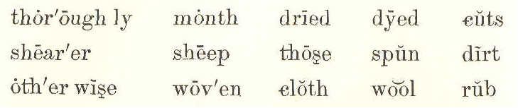
thor'ough ly month dried dyed cuts
shear'er sheep those spun dirt
oth'er wise wov'en cloth wool rub

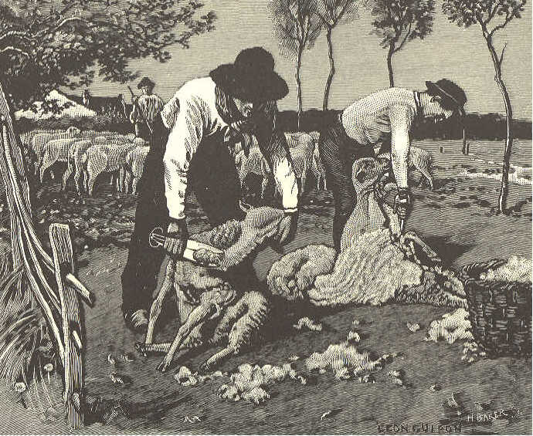

SHEEP-SHEARING.

1. Sheep are washed and sheared some time in the month of June. This should be done quite early in the month, before the hot days begin.
SECOND READER. 55

2. It is fine sport for those who look on, hut not much fun for the sheep.
3. It is best for the sheep to have the wool taken off; otherwise they would suffer in the summer time.
4. When the time comes for washing the sheep, they are driven to a pond or a little river.
5. Then they are thrown into the water, one at a time. The men who are in the water catch them, and squeeze the wet wool with their hands to get the dirt all out of it.
6. Then the wool is thoroughly dried, the sheep are taken to the shearer; and he cuts off the wool with a large pair of shears.
7. It is then dyed, spun, and woven into cloth.
8. In a short time, before the cold winter comes, new wool grows out on the sheep. By the corning of spring there is so much, that it must be cut off again.
56 ECLECTIC SERIES.

LESSON XXV.

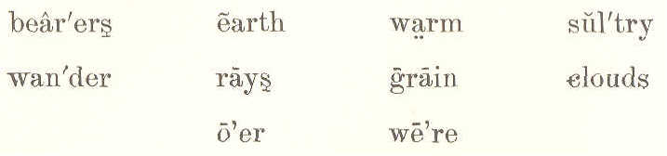
bear'ers earth warm sul'try
wan'der rays grain clouds
o'er we're

THE CLOUDS

1.
"Clouds that wander through the sky, Sometimes low and sometimes high;
In the darkness of the night,
In the sunshine warm and bright.
Ah! I wonder much if you
Have any useful work to do."

2.
"Yes, we're busy night and day,
As o'er the earth we take our way.
We are bearers of the rain
To the grasses, and flowers, and grain;
We guard you from the sun's bright rays,
In the sultry summer days."
SECOND READER 57

LESSON XXVI.
peo'ple for'est
squir'rel cool
near'est tame
hol'low snug
shoul'der miles
sticks
gen'tly
though
Pat'ty
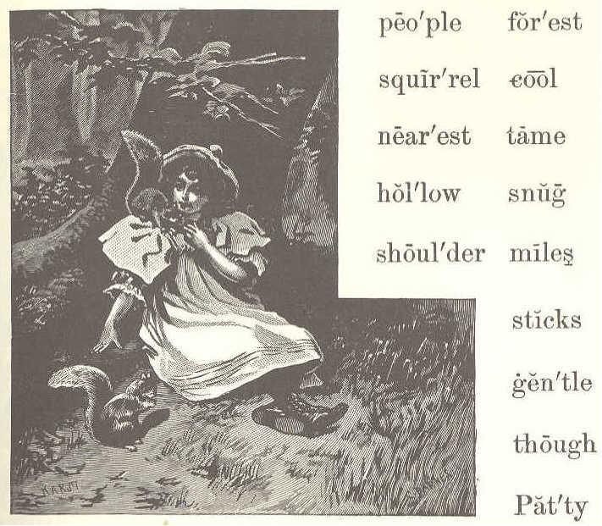

PATTY AND THE SQUIRREL.

1. Little Patty lives in a log house near a great forest. She has no sisters, and her big brothers are away all day helping their father.

2. But Patty is never lonely; for, though the nearest house is miles away,
58 ECLECTIC SERIES.

she has many little friends. Here are two of them that live in the woods.
3. But how did Patty teach them to be so tame? Patty came to the woods often, and was always so quiet and gentle that the squirrels soon found they need not be afraid of her.
4. She brought her bread and milk to eat under the trees, and was sure to leave crumbs for the squirrels.
5. When they came near, she sat very still and watched them. So, little by little, she made them her friends, till, at last, they would sit on her shoulder, and eat from her hand.
6. Squirrels build for themselves summer houses. Those are made of leaves, and sticks, and moss. They are nice and cool for summer, but would never do for the winter cold and snow.
7. So these wise little people find a hollow in an old tree. They make it warm and snug with soft moss and leaves; and here the squirrels live all through the long winter.
SECOND READER. 59

LESSON XXVII.

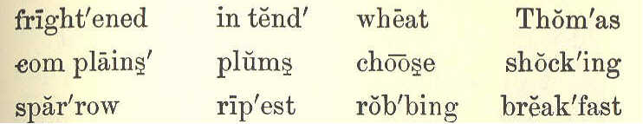
fright'ened int end' wheat Thom'as
com plains' plums choose shock'ing
spar'row rip'est rob'bing break'fast

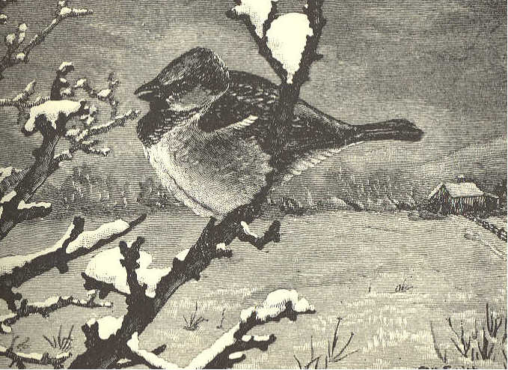
plen'ty share treat tales wait

THE SPARROW.

- Glad to see you, little bird;
'Twas your little chirp I heard:
What did you intend to say?
"Give me something this cold day"?
60 ECLECTIC SERIES.

- That I will, and plenty, too;
All the crumbs I saved for you.
Don't be frightened--here's a treat:
I will wait and see you eat.

- Shocking tales I hear of you;
Chirp, and tell me, are they true?
Robbing all the summer long;
Don't you think it very wrong?

- Thomas says you steal his wheat;
John complains, his plums you eat--
Choose the ripest for your share,
Never asking whose they are.

- But I will not try to know
What you did so long ago:
There's your breakfast, eat away;
Come to see me every day.

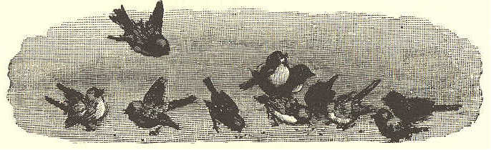
SECOND READER. 61

LESSON XXVIII.
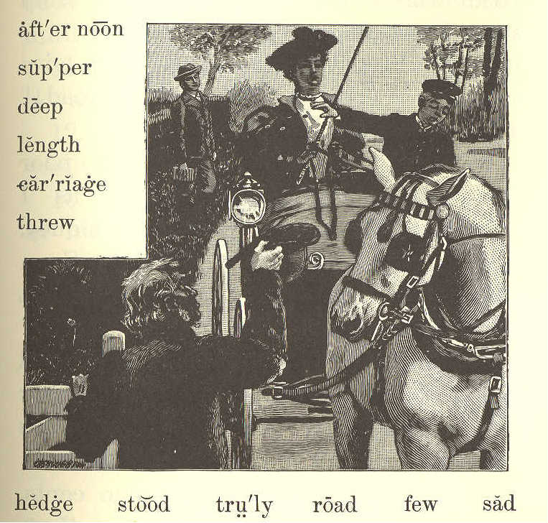
aft'er noon
sup'per
deep
length
car'riage
threw
hedge stood tru'ly road few sad

SAM AND HARRY.

1. One fine summer afternoon, Sam was walking home from school. He went along slowly, reading a book.
2. Sam had spent all his money for the book, but he was a happy boy.
62 ECLECTIC SERIES.

3. At length he came into the highroad, where there was a gate. A blind man stood, holding it open.
4. The poor man said, "Please give me a few cents to buy some bread!" But Sam gave him nothing .
5. What! did Sam give the poor blind man nothing? Yes; for, as I told you, he had spent all his money.
6. So Sam walked on, very sad. Soon after, a fine carriage came up, and in it were Harry and his mother.
7. The blind man stood, and held out his hat. "Let us give the poor man something," said Harry to his mother.
8. His mother gave him some cents. Harry took them, but did not put them into the man's hat.
9. He threw them into the hedge as far as he could. The poor man could not find them, for, you know, ho was blind.
10. Sam had turned back to look at the fine carriage. He saw Harry throw
SECOND READER. 63

the cents into the hedge; so he came back at once, and looked for the money until he found it all for the blind man.
11. This took so long a time, that he almost lost his supper.
12. Which of the boys do you think was truly kind to the poor man?
13. I know which he thanked most in his heart.

LESSON XXIX.
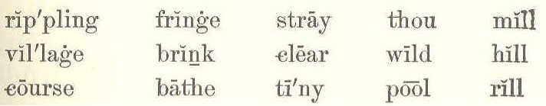
rip'pling fringe stray thou mill
vil'lage brink clear wild hill
course bathe tiny pool rill

THE LITTLE HILL.

- Run, run, thou tiny rill;
Run, and turn the village mill;
Run, and fill the deep, clear pool
In the woodland's shade so cool,
Where the sheep love best to stray
In the sultry summer day;
Where the wild birds bathe and drink,
And the wild flowers fringe the brink.
64 ECLECTIC SERIES.

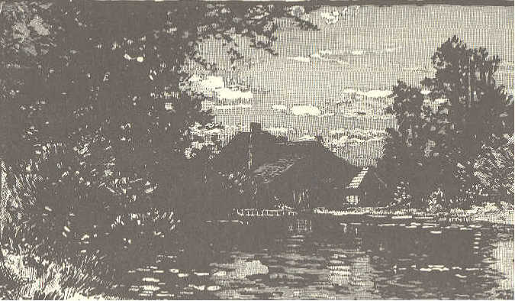

2. Run, run, thou tiny rill,
Round the rocks, and down the hill;
Sing to every child like me;
The birds will join you, full of glee:
And we will listen to the song
You sing, your rippling course along.
SECOND READER. 65

LESSON XXX.

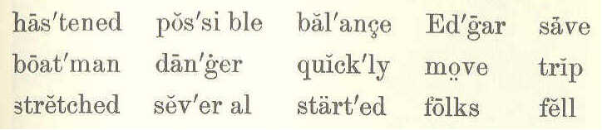
has'tened pos'si ble bal'ance Ed'gar save
boat'man dan'ger quick'ly move trip
stretched sev'er al start'ed folks fell

THE BOAT UPSET.

1. "Sit still, children. Do not move about in the boat," said Mr. Rose to the young folks he was taking for a trip on the water.
2. The boat was a large one, and could not easily be upset. There were in it Mr. and Mrs. Rose, the boatman, and several little boys and girls.
3. "Keep still, please, young gentlemen," said the boatman, when Edgar Rose and Thomas Read began to move from one side to the other.
4. They kept quiet for a short time only. Edgar soon wanted a stick which Thomas held in his hand. He lost his balance in trying to get the stick, and fell into the water.
66 ECLECTIC SERIES.

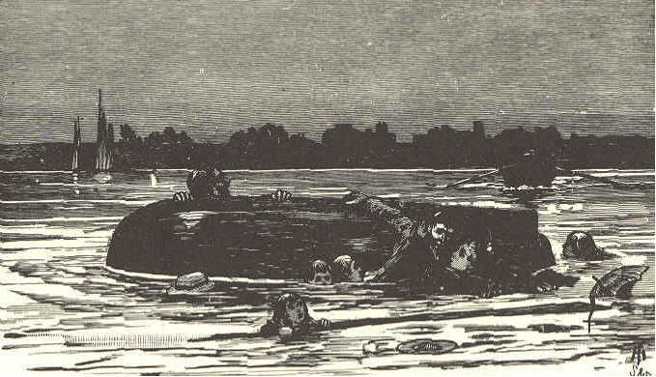

5. Mr. and Mrs. Rose both started up, and stretched out their arms to save him; but in so doing, they upset the boat.
6. Every one fell into the water, and all were in the greatest danger of being drowned.
7. Another boat was near, with but one man in it. He hastened to them as quickly as possible, and saved them from drowning.
8. Children should always be careful and quiet when they are in a boat on the water, and should obey what older people tell them.
SECOND READER. 67

LESSON XXXI.

MARY'S LETTER.

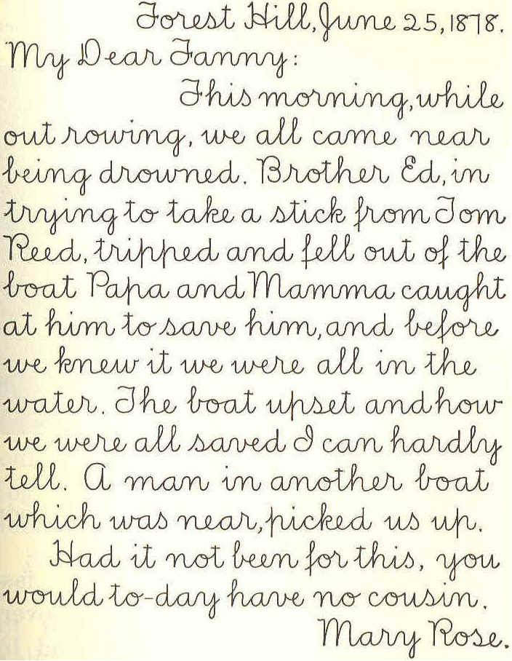
Forest Hill, June 25, 1878
My Dear Fanny:
This morning while
out rowing, we all came near
being drowned. Brother Ed, in
trying to take a stick from Tom
Reed, tripped and fell out of the
boat. Papa and Mamma caught
at him to save him, and before
we knew it we were all in the
water. The boat upset and how
we were all saved I can hardly
tell. A man in another boat
which was near, picked us up.
Had it not been for this, you
would to-day have no cousin.
Mary Rose.

68 ECLECTIC SERIES.

LESSON XXXII.

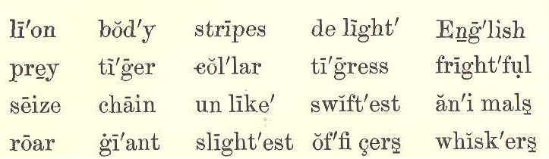
li'on bod'y stripes de light' Eng'lish
prey ti'ger col'lar ti'gress fright'ful
seize chain un like' swift'est an'i mals
roar gi'ant slight'est of'fi cers whisk'ers

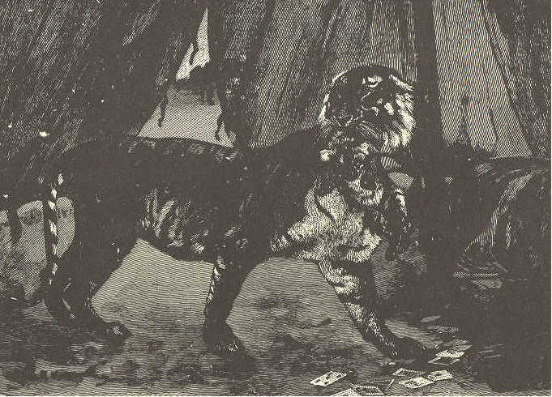

THE TIGER.
1. The tiger is a giant cat. His body is nearly covered with black stripes.
2. Unlike the lion, he runs so fast that the swiftest horse can not overtake him. He goes over the ground by
SECOND READER. 69

making bounds or springs, one after another.
3. By night, as well as by day, the tiger watches for his prey. With a frightful roar, he will seize a man, and carry him off.
4. Have you ever thought what use whiskers are to cats? Lions have great whiskers, and so have tigers and all other animals of the cat kind.
5. Whenever you find an animal with whiskers like the cat's, you may be sure that animal steals softly among branches and thick bushes.
6. By the slightest touch on the tiger's whiskers, he knows when there is anything in his road.
7. A few years ago, some English officers went out to hunt. When coming home from their day's sport, they found a little tiger kitten.
8. They took it with them and tied it, with a collar and chain, to the pole of their tent. It played about, to the delight of all who saw it.

70 ECLECTIC SERIES.

9. One evening, just as it was growing dark, they heard a sound that frightened them greatly. It was the roar of a tiger.
10. The kitten pulled at the chain, and tried to break away. With a sharp cry, it answered the voice outside.
11. All at once, a large tigress bounded into the middle of the tent. She caught her kitten by the neck, and broke the chain which bound it.
12. Then turning to the door of the tent, she dashed away as suddenly as she had come.

LESSON XXXIII.

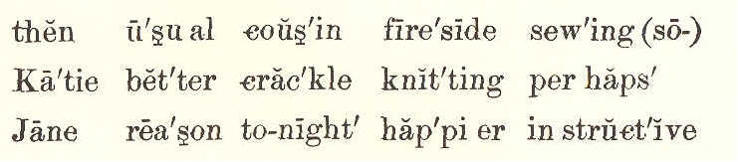
then u'su al cous'in fire'side sew'ing (so-)
Ka'tie bet'ter crac'kle knit'ting per haps'
Jane rea'son to-night' hap'pi er in struct'ive

THE FIRESIDE.

1. One winter night, Mrs. Lord and her two little girls sat by a bright fire
SECOND READER. 71

in their pleasant home. The girls were sewing, and their mother was busy at her knitting.
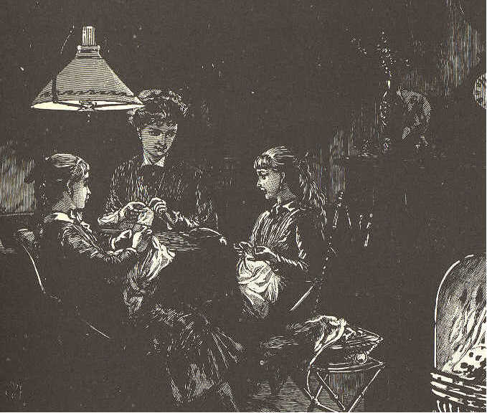
2. At last, Katie finished her work, and, looking up, said, "Mother, I think the fire is brighter than usual. How I love to hear it crackle!"
3. "And I was about to say," cried Mary, "that this is a better light than we had last night."
4. "My dears," said their mother, "it
72 ECLECTIC SERIES.

must be that you feel happier than usual to-night. Perhaps that is the reason why you think the fire better, and the light brighter."
5. "But, mother," said Mary, "I do not see why we are happier now than we were then; for last night cousin Jane was here, and we played 'Puss in the corner' and 'Blind man' until we all were tired."
6. "I know! I know why!" said Katie.
"It is because we have all been doing something useful to-night. We feel happy because we have been busy."
7. "You are right, my dear," said their mother. "I am glad you have both learned that there may be something more pleasant than play, and, at the same time, more instructive."

LESSON XXXIV.

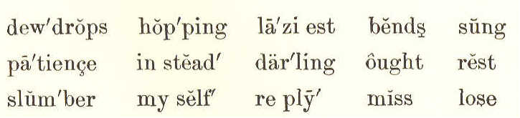
dew'drops hop'ping la'zi est bends sung
pa'tience in stead' dar'ling ought rest
slum'ber my self ' re ply' miss lose
SECOND READER. 73

BIRDIE'S MORNING SONG.

- Wake up, little darling, the birdies are out,
And here you are still in your nest!
The laziest birdie is hopping about;
You ought to be up with the rest.
Wake up, little darling, wake up!

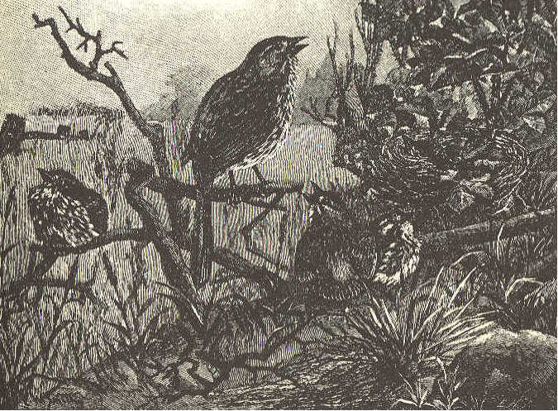

2. Oh, see what you miss when you
slumber so long--
The dewdrops, the beautiful sky!
I can not sing half what you lose in my song;
And yet, not a word in reply.
Wake up, little darling, wake up!
74 ECLECTIC SERIES.

3. I've sung myself quite out of patience with you,
While mother bends o'er your dear head;
Now birdie has done all that birdie can do:
Her kisses will wake you instead!
Wake up, little darling, wake up!
George Cooper.

LESSON XXXV.

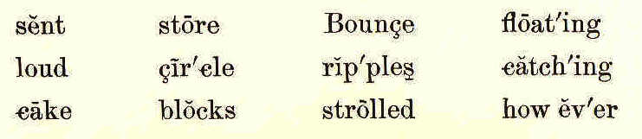
sent store Bounce float'ing
load cir'cle rip'ples catch'ing
cake blocks strolled how ev'er

WILLIE AND BOUNCE.

1. Two fast friends were Willie Brown and his little dog Bounce. Willie could never think of taking a walk without Bounce. Cake and play were equally shared between them.
2. Willie taught his dog many cunning tricks, and often said that Bounce could do almost anything in the world but talk.
3. There came a time, however, when Bounce really told Willie's father some-
SECOND READER. 75
thing, though he could not talk. Let me tell you how he did this.
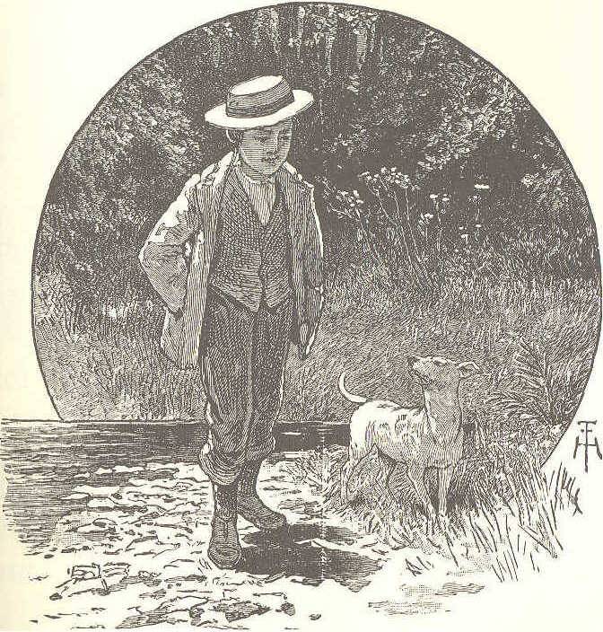
4. It was on a bright summer afternoon. Willie had strolled with Bounce down to the river, which was not more than two blocks from his father's store.
5. Willie began to throw stones into the water, and to watch the ripples as they made one circle after another.
76 ECLECTIC SERIES.

6. Bounce lay on the grass, watching the flies that buzzed around his nose, and catching any that came too near.
7. There were some logs floating in the river near the shore. Willie jumped upon one of them, to see if he could throw a stone across the river.
8. He drew back, and sent the stone with all his might. just as it left his hand, the log turned, and he fell into the water.
9. He was very much frightened, for he did not know how to swim, and there was no one to hear, though he called as loud as he could for help.

LESSON XXXVI.

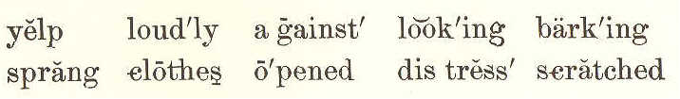
yelp loud'ly against look'ing bark'ing
spring clothes o'pened dis'tress scratched

WILLIE AND BOUNCE.
(CONCLUDED.)

1. Poor little Bounce gave a great yelp of distress. If he had been a
SECOND READER. 77

big water dog, he could have jumped in and brought his master out.

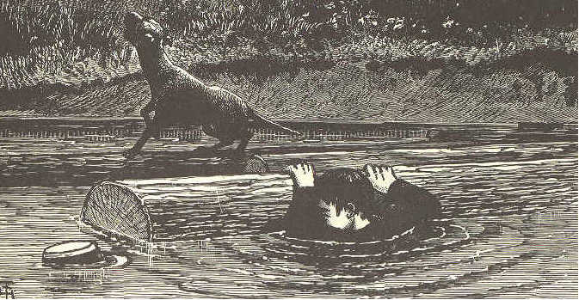

2. He ran up and down the bank two or three times, barking, looking first at Willie and then around. Then he started, as fast as he could run, up the street to the store.
3. When he got there the door was shut, but he scratched against it and barked loudly, until some one came and opened it.
4. He caught hold of Mr. Brown's clothes, then ran to the door, then back again, catching at him, barking, and jumping.
78 ECLECTIC SERIES

5. A friend who was in the store said to Mr. Brown, "Something must be wrong; I would put on my hat, and go with the dog." Bounce, seeing Mr. Brown take his hat, started for the river.
6. Then Mr. Brown thought of Willie. As he came to the river, he saw Willie's hat floating on the water, and his small arm thrown up.
7. He sprang in and caught him just as he was going down for the last time, and quickly carried him to the bank. "Willie soon got over his fright, and no one seemed to be more delighted than Bounce.

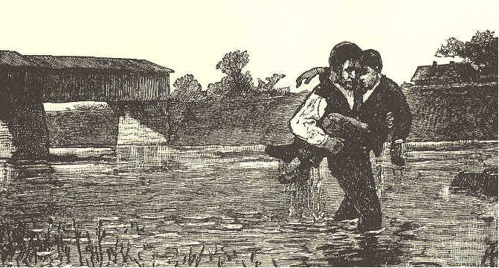
SECOND READER. 79

LESSON XXXVII.

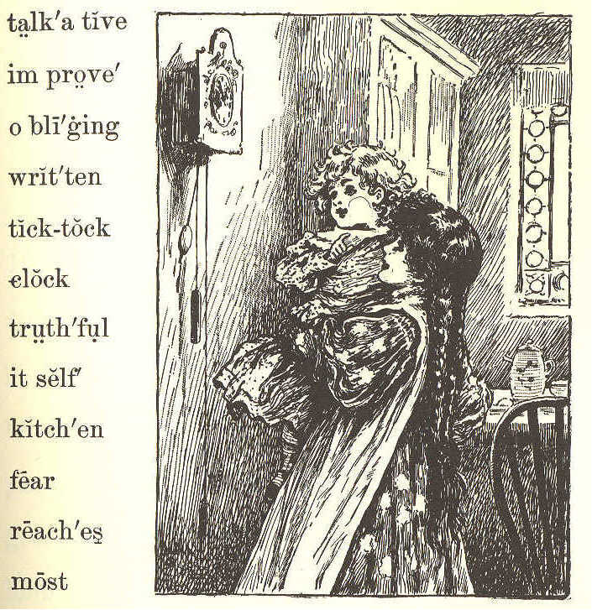
talk'a tive
im prove'
o bli'ging
writ'ten
tick-tock
clock
truth'ful
it self '
kitch'en
fear
reach'es
most

THE KITCHEN CLOCK.

1. Listen to the kitchen clock!
To itself it ever talks,
From its place it never walks;
"Tick-tock-tick-tock: "
Tell me what it says.
80 ECLECTIC SERIES.

2. "I'm a very patient clock,
Never moved by hope or fear,
Though I've stood for many a year;
Tick-tock-tick-tock: "
That is what it says.

3. "I'm a very truthful clock:
People say about the place,
Truth is written on my face;
Tick-tock-tick-tock: "
That is what it says.

4. "I'm a most obliging clock;
If you wish to hear me strike,
You may do it when you like;
Tick-tock-tick-tock: "
That is what it says.

5. "I'm a very friendly clock;
For this truth to all I tell,
Life is short, improve it well;
Tick-tock-tick-tock: "
That is what it says.
SECOND READER. 81

6. What a talkative old clock!
Let us see what it will do
When the hour hand reaches two;
"Ding-ding--tick-tock: "
That is what it says.

LESSON XXXVIII.

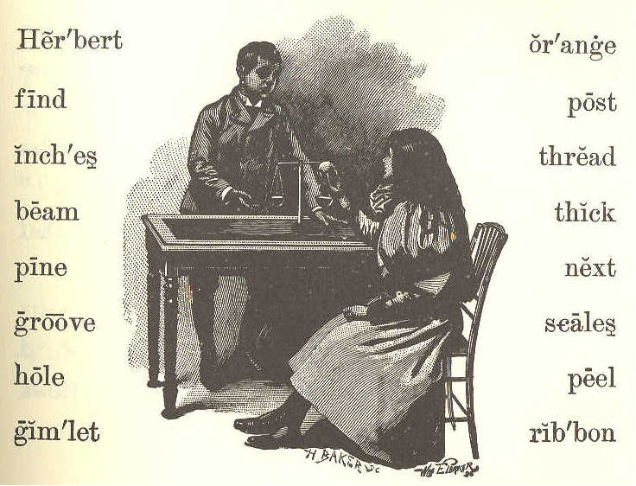
Her'bert or'ange
find post
inch'es thread
beam thick
pine next
groove scales
hole peel
gim'let rib'bon

THE NEW SCALES.

I. "Herbert, will you please peel my orange?" said Lucy. Herbert was reading his new book, but he put it down
82 ECLECTIC SERIES.

at once, and took the orange from his little sister.
2. "Shall I make a pair of scales, Lucy, for you to use when you play store?"
- "Oh yes! but how can you do that'!"
- "I'll show you. First, we must take the peel off in two little cups, one just as large as the other. While I do this, see if you can find me two nice sticks about ten inches long."
5. Lucy ran out to the woodhouse to find the sticks.--" Will these do?"
6. "No, they are too hard. Find some pine sticks if you can."
- "Here are some."
8. "These will do nicely. Now I must make a scale beam and a post. Can you find me a little block for a post, Lucy'!"
9. "Will a ribbon block do, Herbert?"
- "Yes, if it is not too thick."
gimlet: Hand tool with a spiraled shank, a screw tip, and a cross handle; used for boring holes.
- "Here is one an inch thick."
12. "That will be just right. Now get the little gimlet."

SECOND READER 83

13. Herbert worked away until he had made the beam and the post. Then he made a hole in the middle of the block, and put the post in. Next, he put the beam into a little groove at the top of the post, so that it would balance nicely.
14. "Now, Lucy, we must have a needle and some thread. We must put four threads to each cup; then we will tie the threads to the ends of the beam.
15. "There, Lucy, what do you think of that?"
16. "Why, Herbert, that is just as nice as the real scales in father's store; and you may have all my orange for making them."

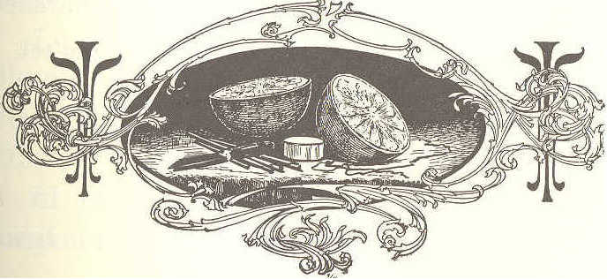
84 ECLECTIC SERIES.

LESSON XXXIX.

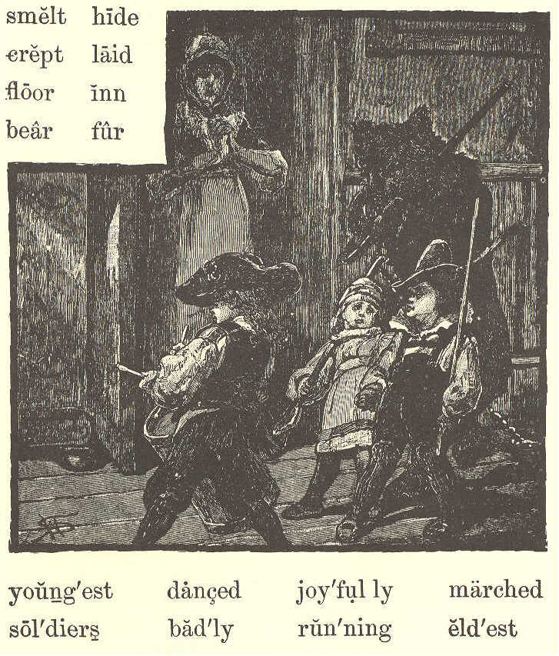
smelt hide
crept laid
floor inn
bear fur
young'est danced joy'ful ly marched
sol'diers bad'ly run'ning eld'est

THE BEAR AND THE CHILDREN.

1. In the parlor of an inn in a small town, sat a man who had been
SECOND READER. 85

going about with a bear. He was waiting for his supper, and the bear was tied up in the yard.
2. Up in the attic, three little children were playing together. The eldest might have been six years old; the youngest, not more than two.
3. Stump! stump! stump! Some one was coming up the stairs.
4. The door flew open suddenly, and there stood the great, shaggy bear. He had got tired of waiting, and had found his way to the stairs.
5. The children were badly frightened. Each one crept into a corner, but the bear found them all out, and smelt their clothes, but did not hurt them.
6. "This must be a great dog," they said, and they began to pat him.
7. Then the bear lay down on the floor, and the youngest boy climbed on his back, hid his head in the shaggy fur, and played at "hide and seek."
8. The eldest boy took his drum and began to strike it, when the bear rose
86 ECLECTIC SERIES.

on his hind legs and danced. At that the children gave a merry shout.
9. The two younger boys took their wooden guns, and gave the bear one. Away they all marched around the room, keeping step.
10. Now the frightened mother of the children came to the door. But the youngest boy shouted, joyfully. "See, we are playing soldiers!"
11. Then the bear's master came running up, and took the bear away.

LESSON XL.
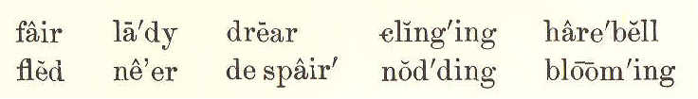
fair la'dy drear cling'ing hare'bell
fled ne'er de spair' nod'ding bloom'ing

THE LITTLE HAREBELL.
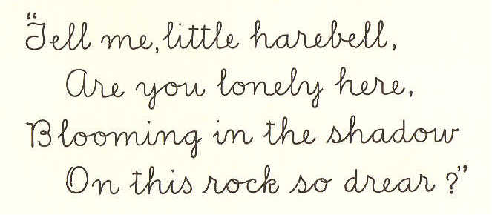
"Tell me, little harebell,
Are you lonely here.
Blooming in the shadow
On this rock so drear?"
harebell: Perennial with slender stems, dense clusters of leaves, and bell-shaped blue or white flowers -- bluebell.
SECOND READER. 87

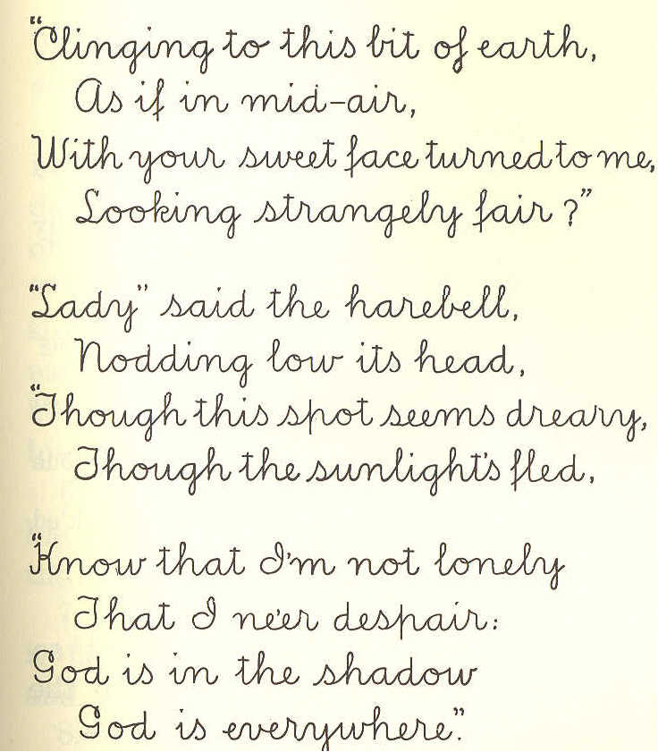
"Clinging to this bit of earth,
As if in mid-air,
With your sweet face turned to me,
Looking strangely fair?"

"Lady" said the harebell,
Nodding low its head,
"Though this spot seem dreary,
Thought the sunlight's fled.

"Know that I'm not lonely
That I ne'er despair.
God is in the shadow
God is everywhere."
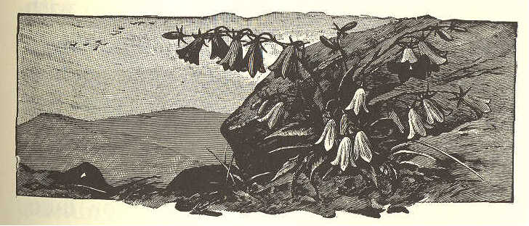

88 ECLECTIC SERIES.

LESSON XLI.

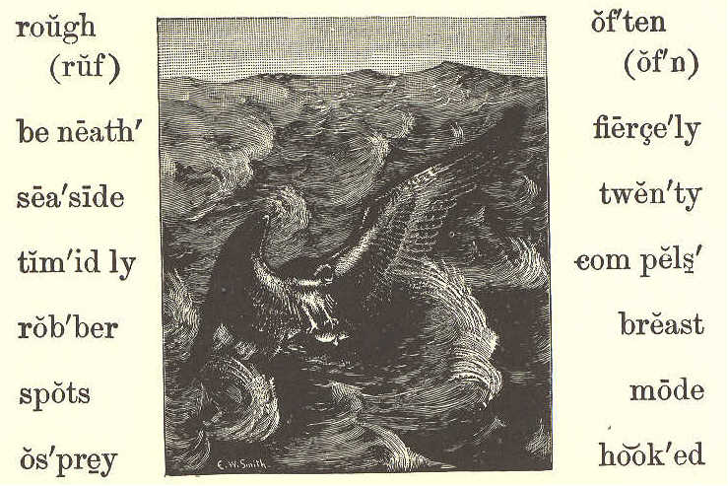
rough (ruf) of'ten (of'n)
be neath' fierce'ly
sea'side twen'ty
tim'id ly com pels'
rob'ber breast
spots mode
os'prey hook'ed

THE FISHHAWK.

1. The fishhawk, or osprey, is not so large as the eagle; but he has, like the eagle, a hooked bill and sharp claws.
2. His color is a dark brown, with black and white spots, and his length is from twenty to twenty-two inches. His breast is mostly white. His tail and wings are long.
3. The fishhawk is often found sitting upon a tree over a pond, or lake,
SECOND READER. 89

or river. He is also found by the seaside.
4. He watches the fish as they swim in the water beneath him; then he darts down suddenly and catches one of them.
5. When he catches a fish in his sharp, rough claws, he carries it off to eat, and, as he flies away with it for his dinner, an eagle sometimes meets him.
6. The eagle flies at him fiercely with his sharp bill and claws, and compels the hawk to drop the fish.
7. Then the eagle catches the fish as it falls, before it reaches the ground, and carries it off.
8. The poor fish hawk, with a loud cry, timidly flies away. He must go again to the water and catch another fish for his dinner.
9. Thus you see, that the eagle is a robber. He robs fishhawks, whose only mode of getting a living is by catching fish.
90 ECLECTIC SERIES.

LESSON XLII.

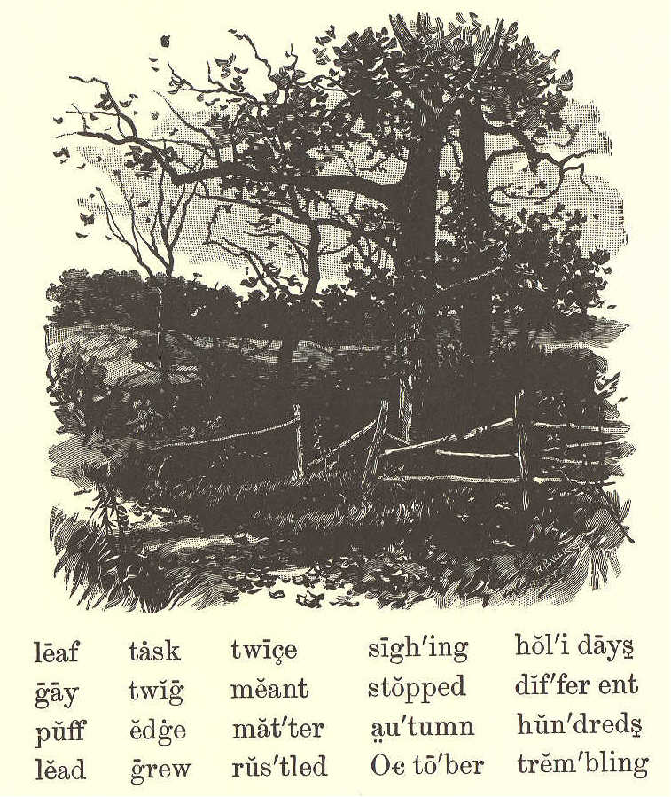
leaf task twice sigh'ing hol'i days
gay twig meant stopped dif'fer ent
puff edge mat'ter au'tumn hun'dreds
lead grew rus'tled Oc to'ber trem'bling

WHAT THE LEAF SAID.

1. Once or twice a little leaf was heard to cry and sigh, as leaves often
SECOND READER. 91

do, when a gentle wind is blowing. And the twig said, "What is the matter, little leaf?"
2. "The wind," said the leaf, "just told me that one day it would pull me off, and throw me on the ground to die."
3. The twig told it to the branch, and the branch told it to the tree. When the tree heard it, it rustled all over, and sent word back to the trembling leaf.
4. "Do not be afraid," it said; "hold on tight, and you shall not go off till you are ready."
5. So the leaf stopped sighing, and went on singing and rustling. It grew all the summer long till October. And when the bright days of autumn came, the leaf saw all the leaves around growing very beautiful.
6. Some were yellow, some were brown, and many were striped with different colors. Then the leaf asked the tree what this meant.
92 ECLECTIC SERIES.

7. The tree said, "All these leaves are getting ready to fly away, and they have put on these colors because of their joy."
8. Then the little leaf began to want to go, and grew very beautiful in thinking of it. When it was gay in colors, it saw that the branches of the tree had no bright colors on them.
9. So the leaf said, "O branch! why are you lead-colored while we are all beautiful and golden?"
10. "We must keep on our working clothes," said the tree, "for our work is not yet done; but your clothes are for holidays, because your task is now over."
11. Just then a little puff of wind came, and the leaf let go without thinking, and the wind took it up and turned it over and over.
12. Then it fell gently down under the edge of the fence, among hundreds of leaves, and has never waked to tell us what it dreamed about.
SECOND READER. 93

LESSON XLIII.

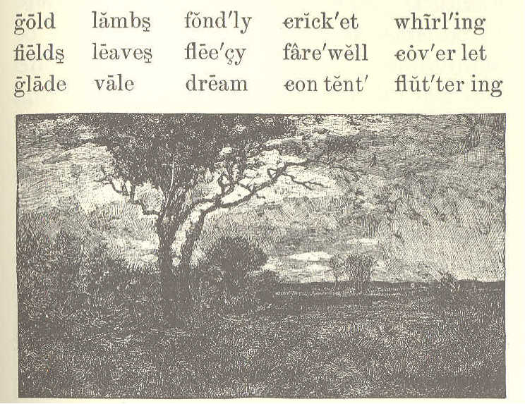
gold lambs fond'ly crick'et whirl'ing
fields leaves flee'cy fare'well cov'er let
glade vale dream con tent' flut'ter ing

THE WIND AND THE LEAVES.
1.
"Come, little leaves," said the wind one day.
"Come o'er the meadows with me, and play;
Put on your dress of red and gold
Summer is gone, and the days grow cold."

2.
Soon as the leaves heard the wind's loud call,
Down they came fluttering, one and all;
Over the brown fields they danced and flew,
Singing the soft little songs they knew.
94 ECLECTIC SERIES.

3.
"Cricket, good-by, we've been friends so long;
Little brook, sing us your farewell song,--
Say you are sorry to see us go;
Ah! you will miss us, right well we know.

4.
"Dear little lambs, in your fleecy fold,
Mother will keep you from harm and cold;
Fondly we've watched you in vale and glade;
Say, will you dream of our loving shade?"

5.
Dancing and whirling, the little leaves went;
Winter had called them, and they were content.
Soon fast asleep in their earthy beds,
The snow laid a coverlet over their heads.

George Cooper.

LESSON XLIV.

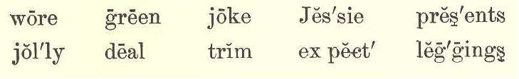
wore green joke Jessie pres'ents
jol'ly deal trim ex pect' leg'gings

MAMMA'S PRESENT.

1. Jessie played a good joke on her mamma. This is the way she did it.
SECOND READER. 95

2. Jessie had gone to the woods with Jamie and Joe to get green branches to trim up the house for Christmas. She wore her little cap, her white furs, and her red leggings.

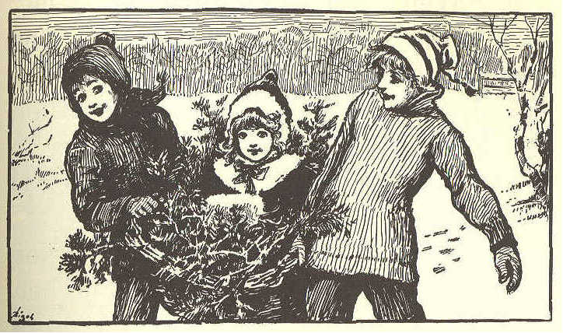

3. She was a merry little girl, indeed; but she felt sad this morning because her mother had said, "The children will all have Christmas presents, but I don't expect any for myself. We are too poor this year."
4. When Jessie told her brothers this, they all talked about it a great deal. "Such a good, kind mamma, and no Christmas present! It's too bad."
96 ECLECTIC SERIES.

5. "I don't like it," said little Jessie, with a tear in her eye.
- "Oh, she has you," said Joe.
7. "But I am not something new," said Jessie.
8. "Well, you will be new, Jessie," said Joe, "when you get back. She has not seen you for an hour."
9. Jessie jumped and laughed. "Then put me in the basket, and carry me to mamma, and say, 'I am her Christmas present.' "
10. So they set her in the basket, and put green branches all around her. It was a jolly ride. They set her down on the doorstep, and went in and said, "There's a Christmas present out there for you, mamma."
11. Mamma went and looked, and there, in a basket of green branches, sat her own little laughing girl.
12. "Just the very thing I wanted most," said mamma.
13. "Then, dear mamma," said Jessie, bounding out of her leafy nest, "I
SECOND READER. 97

should think it would be Christmas for mammas all the time, for they see their little girls every day."

LESSON XLV.

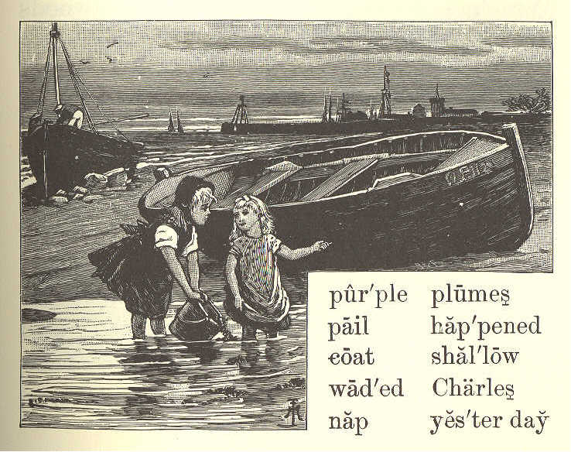
pur'ple plumes
pail hap'pened
coat shal'low
wad'ed Charles
nap yes'ter day

MARY'S STORY.

1. Father, and Charles, and Lucy, and I went to the beach yesterday. We took our dinner, and stayed all day.
98 ECLECTIC SERIES.

2. Father and Charles went out a little way from the shore in a boat, and fished, while Lucy and I gathered sea mosses.
3. We took off our shoes and stockings, and waded into the shallow water. We had a pail to put our seaweeds in.
4. We found such beautiful ones. Some wore purple, some pink, and some brown. When they were spread out in the water, the purple ones looked like plumes, and the brown ones like little trees.
5. Such a funny thing happened to Lucy. She slipped on a stone, and down she went into the water. How we both laughed! But the wind and sun soon dried Lucy's dress.
6. Then father came and took us in the boat for a row. After that we had a picnic dinner in the woods.
7. Then father spread his coat on the grass, and took a nap while we children played on the beach.
SECOND READER. 99

LESSON XLVI.

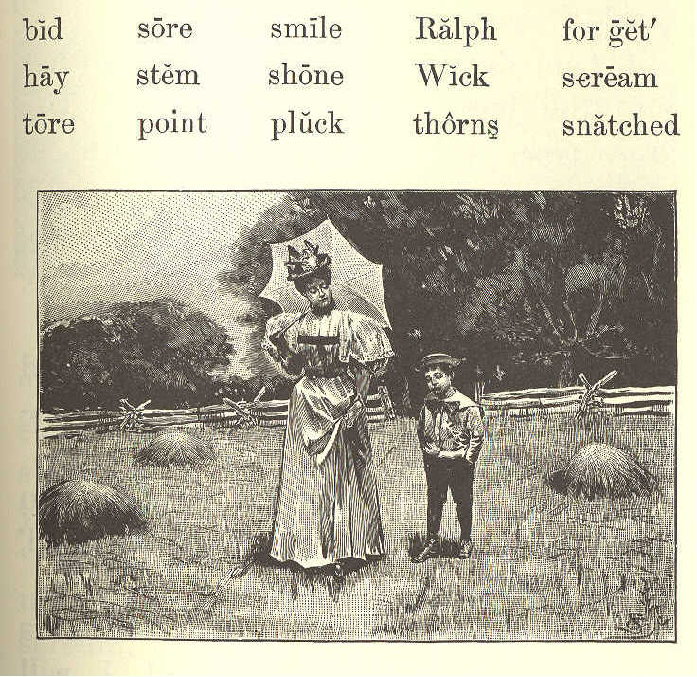
bid sore smile Ralph for get'
hay stem shone Wick scream
tore point pluck thorns snatched

RALPH WICK.
1. Ralph Wick was seven years old. In most things he was a fine boy, but he was too apt to cry.
2. When he could not have what. he wanted, he would cry for it and say, "I will have it."
100 ECLECTIC SERIES.

3. If he was told that it would hurt him, and he could not have it, he would begin to tease and cry.
4. One day, he went with his mother into the fields. The sun shone. The grass was cut. The flowers were in bloom.
5. Ralph thought he was, for once, a good boy. A smile was on his face. He wished to do as he was told.
6. He said, "Mother, I will be good now. I will do as you bid me. Please let me toss this hay."
7. "That I will," said his mother. So they threw the hay, as Ralph wished, and he was very happy.
8. "Now you must be tired," said his mother. "Sit down here, and I will get a nice red rose for you."
9. "I would like to have one," said Ralph. So his mother brought the red rose to him.
10. "Thank you, mother," he said. "But you have a white one, also. Please give me that."
SECOND READER. 101

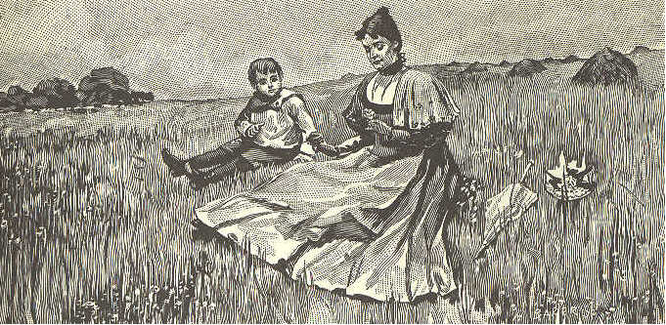

11. "No, my dear," said his mother. "See how many thorns it has on its stem. You must not touch it. If you should try to pluck a rose like this, you would be sure to hurt your hand."
12. When Ralph found that he could not have the white rose, he began to scream, and snatched it. But he was soon very sorry. The thorns tore his hand. It was so sore he could not use it for some time.
13. Ralph did not soon forget this. When he wanted what he should not have, his mother would point to his sore hand. He at last learned to do as he was told.
102 ECLECTIC SERIES

LESSON XLVII.

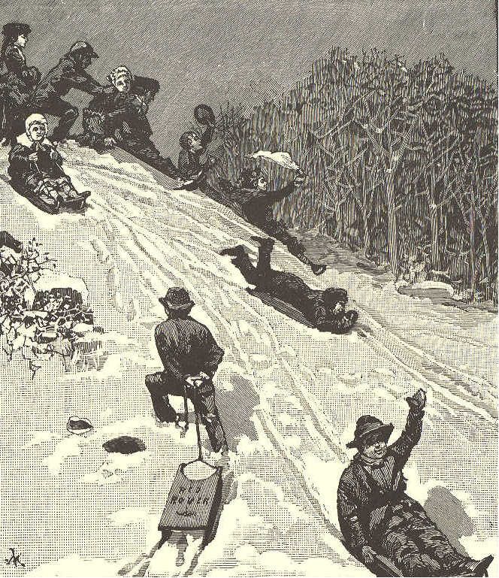
COASTING DOWN THE HILL.
slope voic'es rush'ing beam'ing
track cheeks flood'ing laugh'ter
health a glow' coast'ing trudg'ing
frost'y Is'a bel pleas'ure land'scape
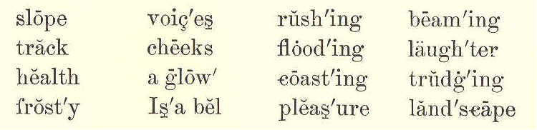
SECOND READER. 103

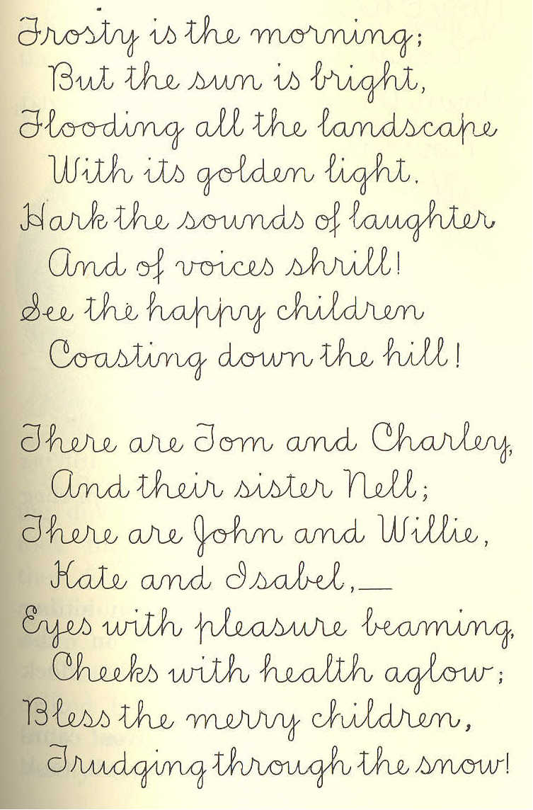
Frosty is the morning;
But the sun is bright,
Flooding all the landscape
With its golden light.
Hark the sounds of laughter
And the voices shrill!
See the happy children
Coasting down the hill.

There are Tom and Charley,
And their sister Nell;
There are John and Willie,
Kate and Isabel,--
Eyes with pleasure beaming,
Cheeks with health aglow;
Bless the merry children,
Trudging through the snow!
104 ECLECTIC SERIES.

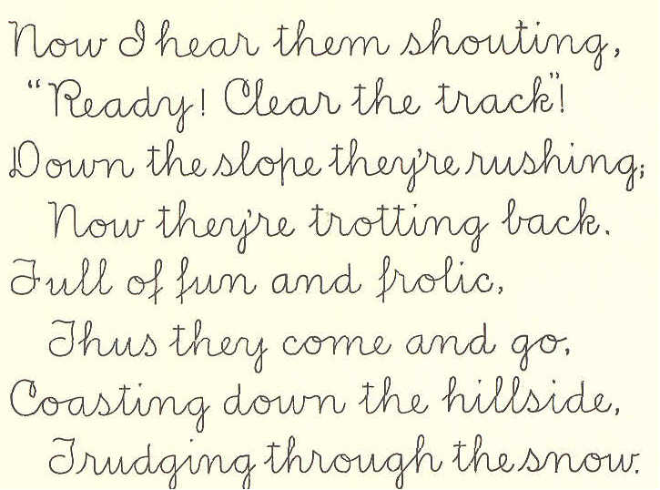
Now I hear them shouting,
"Ready! Clear the track!"
Down the slope they're rushing,
Now they're trotting back.

Full of fun and frolic,
Thus they come and go.
Coating down the hillside,
Trudging through the snow.

LESSON XLVIII.

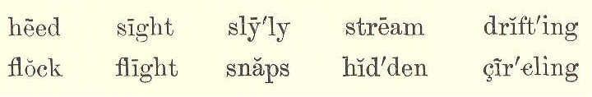
heed sight sly'ly stream drift'ing
flock flight snaps hid'den cir'cling

THE FOX AND THE DUCKS.
1. On a summer day, a man sitting on the bank of a river, in the shade of some bushes, watched a flock of ducks on the stream.
2. Soon a branch with leaves came drifting among them, and they all took
SECOND READER. 105

wing. After circling in the air for a little time, they settled down again on their feeding ground.

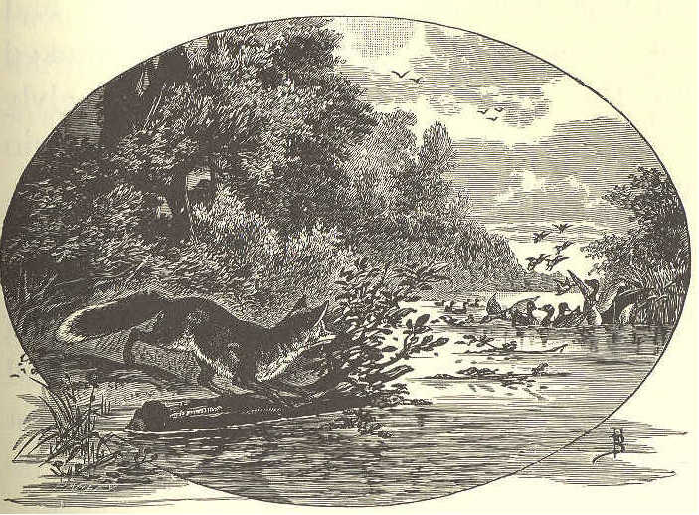

3. Soon another branch came drifting down among them, and again they took flight from the river; but when they found the branch had drifted by and done them no harm, they flew down to the water as before.
4. After four or five branches had drifted by in this way, the ducks gave little heed to them. At length, they hardly tried to fly out of their way,
106 ECLECTIC SERIES.

even when the branches nearly touched them.
5. The man who had been watching all this, now began to wonder who had set these branches adrift. He looked up the stream, and spied a fox slyly watching the ducks. "What will he do next?" thought the man.
6. When the fox saw that the ducks were no longer afraid of the branches, he took a much larger branch than any he had yet used, and stretched himself upon it so as to be almost hidden. Then he set it afloat as he had the others.
7. Right among the flock drifted the sly old fox, and, making quick snaps to right and left, he seized two fine young ducks, and floated off with them.
8. The rest of the flock flew away in fright, and did not come back for a long time.
9. The fox must have had a fine dinner to pay him for his cunning, patient work.
SECOND READER. 107

LESSON XLIX.

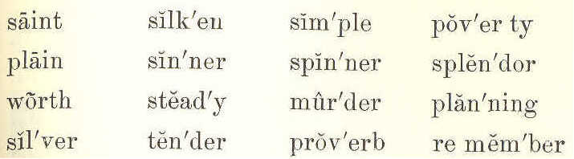
saint silk'en sim'ple pov'er ty
plain sin'ner spin'ner splen'dor
worth stead'y mur'der plan'ning
sil'ver ten'der prov'erb re mem'ber

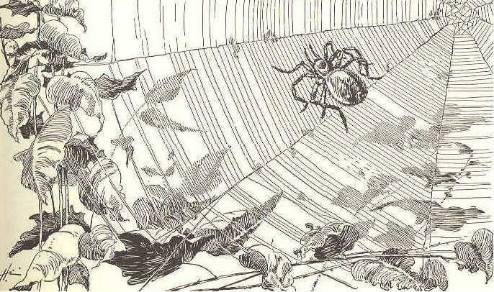

PRETTY IS THAT PRETTY DOES.

1. The spider wears a plain brown dress,
And she is a steady spinner;
To see her, quiet as a mouse,
Going about her silver house,
You would never, never, never guess
The way she gets her dinner.
108 ECLECTIC SERIES.

2. She looks as if no thought of ill
In all her life had stirred her;
But while she moves with careful tread, And while she spins her silken thread,
She is planning, planning, planning still
The way to do some murder.

3. My child, who reads this simple lay,
With eyes down-dropt and tender, Remember the old proverb says
That pretty is which pretty does,
And that worth does not go nor stay
For poverty nor splendor.

4. 'Tis not the house, and not the dress,
That makes the saint or sinner.
To see the spider sit and spin,
Shut with her walls of silver in,
You would never, never, never guess
The way she gets her dinner.
Alice Cary.
SECOND READER. 109

LESSON L.
civil Pe'ter Tow'ser ap pear'
a lone' Pin'dar per'sons trav'el ers
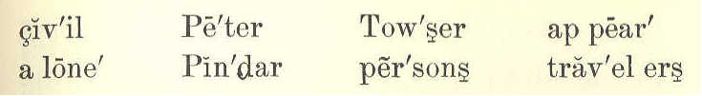

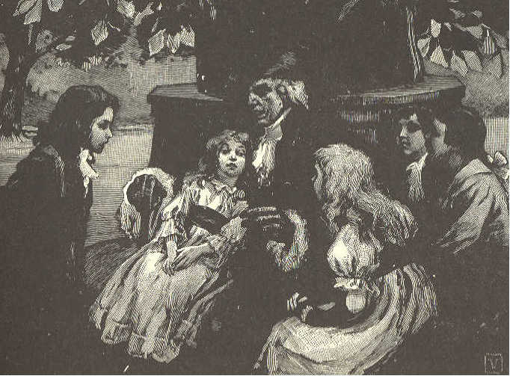

THE STORY-TELLER

1. Peter Pindar was a great storyteller. One day, as he was going by the school, the children gathered around him.
2. They said, "Please tell us a story we have never heard." Ned said, "'Tell us something about boys and dogs."
110 ECLECTIC SERIES.

3. "Well," said Peter, "I love to please good children, and, as you all appear civil, I will tell you a new story; and it shall be about a boy and some dogs, as Ned asks.
4. "But before we begin, let us sit down in a cool, shady place. And now, John, you must be as still as a little mouse. Mary, you must not let Towser bark or make a noise.
5. "A long way from this place, there is a land where it is very cold, and much snow falls.
6. "The hills are very high there, and traveler's are often lost among them. There are men there who keep large dogs. These are taught to hunt for people lost in the snow.
7. "The dogs have so fine a scent, that they can find persons by that alone.
8. "Sometimes it is so dark, that they can not see anything. Those who are lost often lie hid in the snowdrifts. "
SECOND READER. 111

LESSON LI.

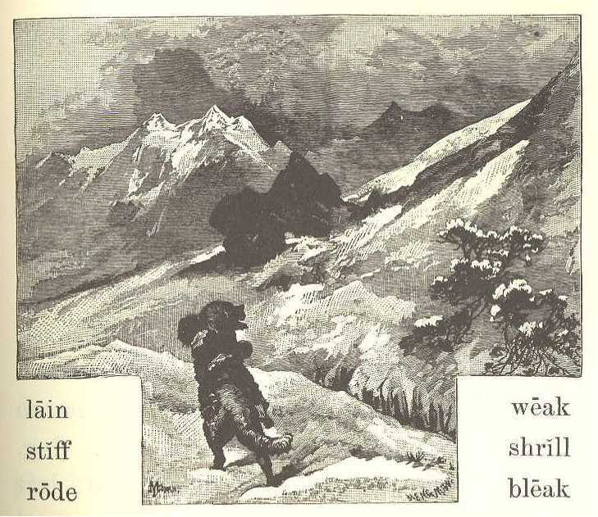
lain weak
stiff shrill
rode bleak

THE STORY TELLER
(CONCLUDED)

1. "One cold, bleak night, the snow fell fast, and the wind blew loud and shrill. It was quite dark. Not a star was to be seen in the sky.
2. "These good men sent out a dog, to hunt for those who might want help.
112 ECLECTIC SERIES.

In an hour or two, the dog was heard coming back.
3. "On looking out, they saw him with a boy on his back. The poor child was stiff with cold. He could but just hold on to the dog's back.
4. "He had lain for a long time in the snow, and was too weak to walk.
5. "He felt something pull him by the coat, and heard the bark of a dog. He put out his hand, and felt the dog. The dog gave him another pull.
6. "This gave the poor boy some hope, and he took hold of the dog. He drew himself out of the snow, but ho could not stand or walk.
7. "He got on the dog's back, and put his arms round the dog's neck, and held on. He felt sure that the dog did not mean to do him any harm.
8. "Thus he rode all the way to the good men's house.
9. "They took care of him, till the snow was gone. Then they sent him to his home."
SECOND READER. 113

LESSON LII.

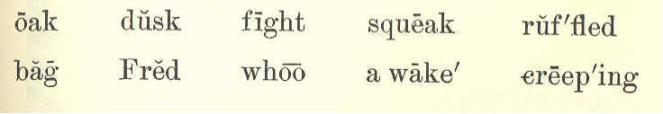
oak dusk fight squeak ruf'fled
bag Fred whoo a wake' creep'ing

THE OWL.

1. "Where did you get that owl, Harry?"
2. "Fred and I found him in the old, hollow oak."
3. "How did you know he was there?"
4. "I'll tell you. Fred and I were playing 'hide and seek' round the old barn, one night just at dusk.
5. "I was just creeping round the corner, when I heard a loud squeak, and a big bird flew up with something in his claws.
6. "I called Fred, and we watched him as he flew to the woods. Fred thought the bird was an owl, and that he had a nest in the old oak.
7. "The next day we went to look
114 ECLECTIC SERIES.

for him, and, sure enough, he was there." 8. "But how did you catch him? I should think he could fight like a good fellow with that sharp bill."
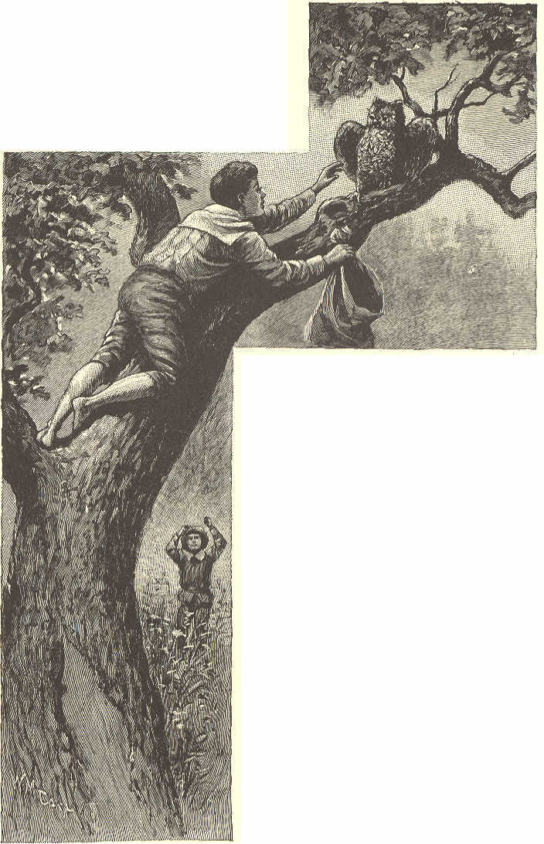
9. "He can when he is wide awake; but owls can't see very well in the daytime, and he was taking a nap.
10. "He opened his great eyes, and ruffled up his feathers, and said, "Whoo! Whoo!' 'Never mind who,' Fred said, and slipped him into a bag."
SECOND READER. 115

LESSON LIII.

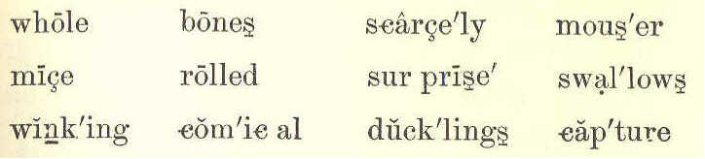
while bones scarce'ly mous'er
mice rolled sur prised' swal'lows
wink'ing com'ic al duck'lings cap'ture

THE OWL.
(CONCLUDED.)

1. "What are you going to do with him, Harry?"
2. "Let him go. He doesn't like this cage half so well as his old oak tree. A young owl can be tamed easily, but this one is too old to tame."
3. "But won't he catch all your ducklings and little chickens?"
4. "No, not while there are any rats or mice around. Father says an owl is a good mouser, and can catch more mice than half a dozen cats."
5. "I'm glad I had a look at him before you let him go. What soft feathers he has!"
6. "Yes, he can fly so softly that
116 ECLECTIC SERIES.

you can scarcely hear him, and for this reason he can easily surprise and capture his prey."
7. "How comical he looks, winking his big eyes slowly, and turning his head from side to side!"

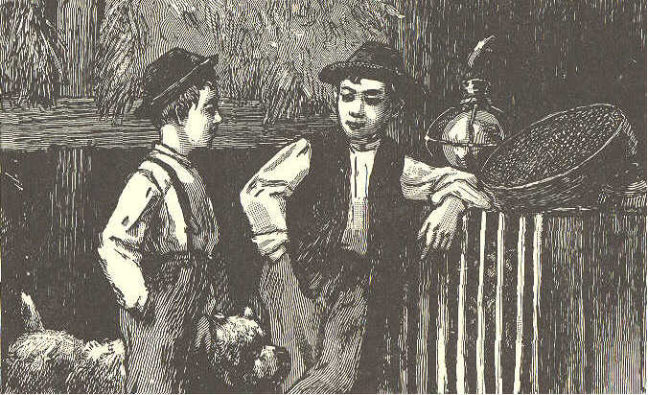

8. "Yes; he is watching your dog. Be still. Bounce!
9. "We have just found out a funny thing about his way of eating. He breaks the bones of a mouse, and then swallows it whole. After an hour or two, he throws up the bones and fur rolled up in a little ball."
SECOND READER. 117

LESSON LIV.

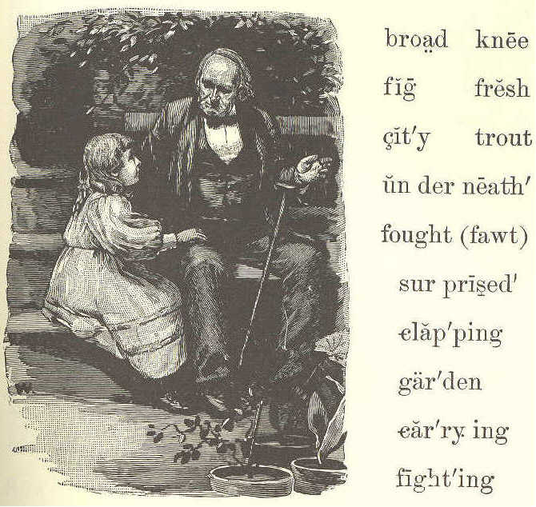
broad knee
fig fresh
city trout
un der neath'
fought (fawt)
sur prised'
clap'ping
gar'den
car'ry ing
fight'ing

GRANDFATHER'S STORY.

1. "Come and sit by my knee, Jane, and grandfather will tell you a strange story.
2. "One bright Summer day, I was in a garden in a city, with a friend. "We rested underneath a fig tree. The broad leaves were green and fresh.
118 ECLECTIC SERIES.

3. "We looked up at the ripe, purple figs. And what do you think came down through the branches of the fig tree over our heads?"
4. "Oh, a bird, grandfather, a bird!" said little Jane, clapping her hands.
5. "No, not a bird. It was a fish; a trout, my little girl."
6. "Not a fish, grandfather! A trout come through the branches of a tree in the city'! I am sure you must be in fun."
7. "No, Jane, I tell you the truth. My friend and I were very much surprised to see a fish falling from a fig tree.
8. "But we ran from under the tree, and saw a fishhawk flying, and an eagle after him.
9. "The hawk had caught the fish, and was carrying it home to his nest, when the eagle saw it and wanted it.
10. "They fought for it. The fish was dropped, and they both lost it. So much for fighting!"
SECOND READER. 119

LESSON LV.

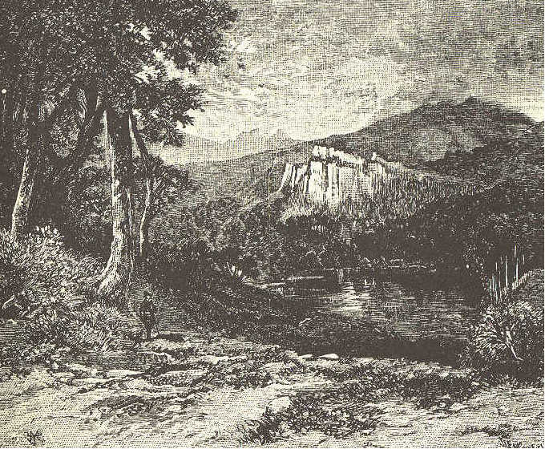
flow wide steep lakes twin'kling

GOD IS GREAT AND GOOD.

1. I know God made the sun
To fill the day with light;
He made the twinkling stars
To shine all through the night.

2. He made the hills that rise
So very high and steep;
120 ECLECTIC SERIES.

He made the lakes and seas,
That are so broad and deep.

3. He made the streams so wide,
That flow through wood and vale;
He made the rills so small,
That leap down hill and dale.

4. He made each bird that sings
So sweetly all the day;
He made each flower that springs
So bright, so fresh, so gay.

5. And He who made all these,
He made both you and me;
Oh, let us thank Him, then,
For great and good is He.

LESSON LVI.

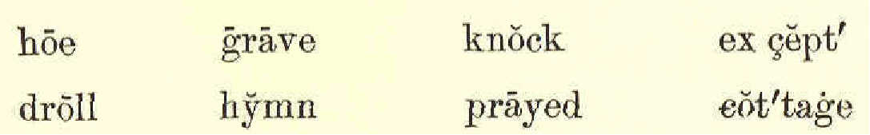
hoe grave knock ex cept'
droll hymn prayed cot'tage
SECOND READER. 121

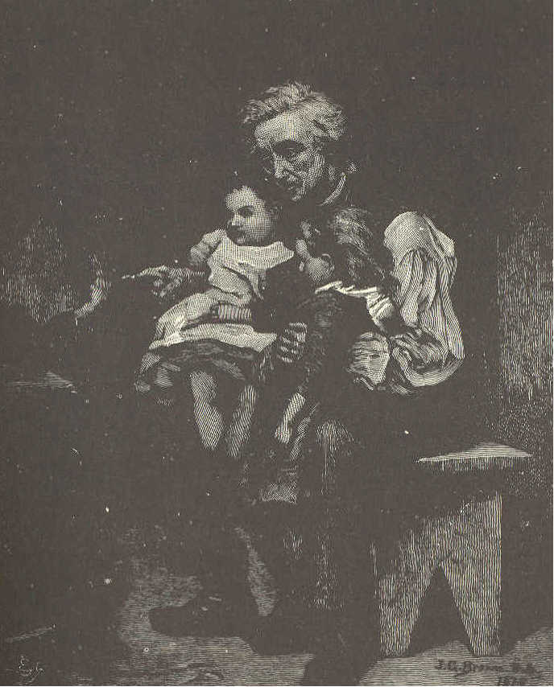

A GOOD OLD MAN.

1. There once lived an old man in a snug, little cottage. It had two rooms and only two windows. A small garden lay just behind it.
122 ECLECTIC SERIES.

2. Old as the poor man was, he used to work in the fields. Often he would come home very tired and weak, with his hoe or spade on his shoulder.
3. And who do you think met him at the door! Mary and Jane, his two little grandchildren.
4. They were too young to work, except to weed in the garden, or bring water from the spring.
5. In winter, as they were too poor to buy much wood or coal, they had little fire; so they used to sit close together to keep warm. Mary would sit on one of the old man's knees, and Jane on the other.
6. Sometimes their grandfather would tell them a droll story. Sometimes he would teach them a hymn.
7. He would often talk to them of their father, who had gone to sea, or of their good, kind mother, who was in her grave. Every night he prayed God to bless them, and to bring back their father in safety.
SECOND READER. 123

8. The old man grew weaker every year; but the little girls were glad to work for him, who had been so good to them.
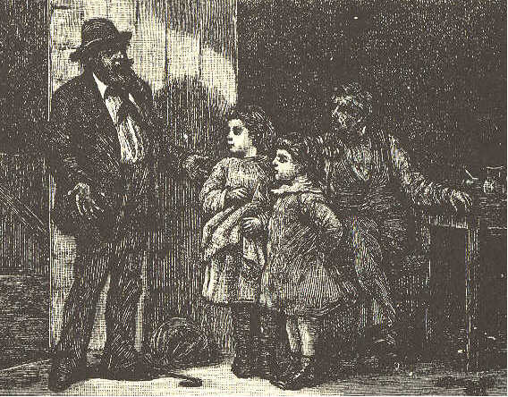
9. One cold, windy night, they heard a knock at the door. The little girls ran and opened it. Oh, joy to them! There stood their father.
10. He had been at sea a long time. He had saved some money, and had now come home to stay.
11. After this the old man did not have to work. His son worked for him, and his grandchildren took care of him. Many happy days they spent together.
124 ECLECTIC SERIES.

LESSON LVII.
dined gay'ly doc'tor glut'ton
needs live'ly a'corns read'ers
tastes Lau'ra greed'y tem'pers
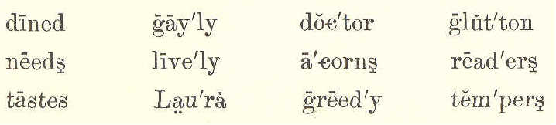

THE GREEDY GIRL.

1. Laura English is a greedy little girl. Indeed, she is quite a glutton. Do you know what a glutton is? A glutton is one who eats too much, because the food tastes well.
2. Laura's mother is always willing she should have as much to eat as is good for her; but sometimes, when her mother is not watching, she eats so much that it makes her sick.
3. I do not know why she is so silly. Her kitten never eats more than it needs. It leaves the nice bones on the plate, and lies down to sleep when it has eaten enough.
4. The bee is wiser than Laura. It
SECOND READER. 125

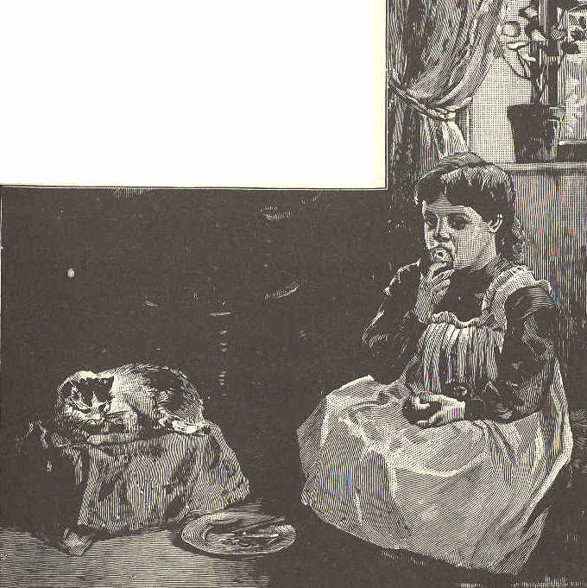

flies all day among the flowers to gather honey, and might eat the whole time if it pleased. But it eats just enough, and carries all the rest to its hive.
5. The squirrel eats a few nuts or acorns, and frisks about as gayly as if he had dined at the king's table.
6. Did you ever see a squirrel with a nut in his paws? How bright and lively he looks as he eats it!
126 ECLECTIC SERIES.

7. If he lived in a house made of acorns, he would never need a doctor. He would not eat an acorn too much.
8. I do not love little girls who eat too much. Do you, my little readers?
9. I do not think they have such rosy cheeks, or such bright eyes, or such sweet, happy tempers as those who eat less.

LESSON LVIII.

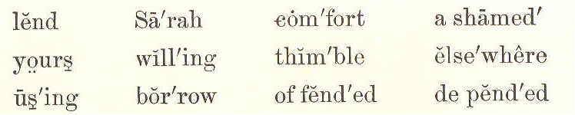
lend Sa'rah com'fort a shamed'
your wil'ling thim'ble else'where
us'ing bor'row of fend'ed de pend'ed

A PLACE FOR EVERYTHING.

Mary. I wish you would lend me your thimble, Sarah. I can never find my own.
Sarah. Why is it, Mary, you can never find it?
Mary. How can I tell? But if you will not lend me yours, I can borrow one elsewhere.
SECOND READER. 127

Sarah. I am willing to lend mine to you, Mary. But I would very much like to know why you come to me to borrow so often.

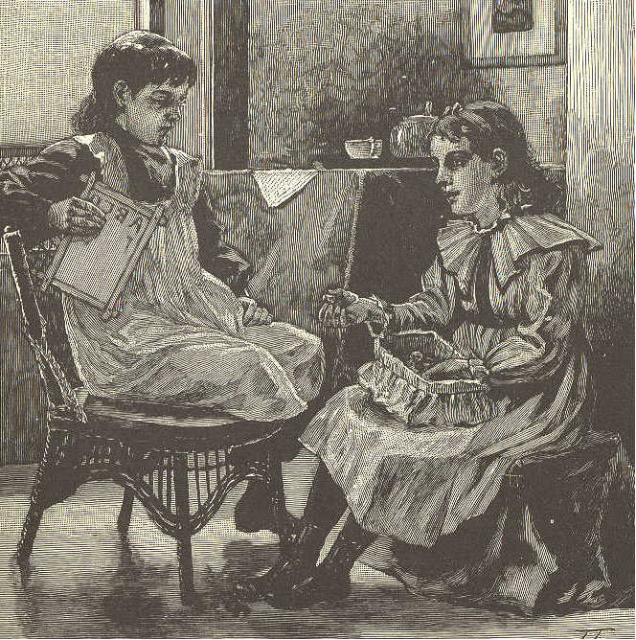

Mary. Because you never lose any of your things, and always know where to find them.

Sarah. And why do I always know where to find my things?
128 ECLECTIC SERIES.

Mary. I do not know why, I am sure. If I did know, I might sometimes find my own.
Sarah. I will tell you the secret. I have a place for everything, and I put everything in its place when I have done using it.
Mary. O Sarah! who wants to run and put away a thing as soon as she has used it, as if her life depended upon it?
Sarah. Our life does not depend upon it, but our comfort does, surely. How much more time will it take to put a thing in its place, than to hunt for it or to borrow whenever you want to use it ?
Mary. Well, Sarah, I will never borrow of you again, you may depend upon it.
Sarah. You are not offended with me, I hope.
Mary. No, but I am ashamed. Before night, I will have a place for everything, and then I will keep everything in its place. You have taught me a lesson that I shall remember.

SECOND READER. 129

LESSON LIX.

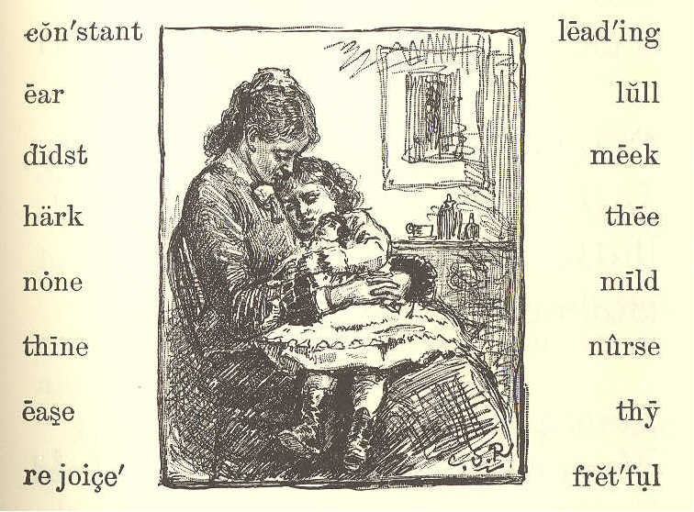
con'stant lead'ing
ear lull
didst meek
hark thee
none mild
thine nurse
ease thy
re joice' fret'ful

MY MOTHER.
Hark! My mother's voice I hear,
Sweet that voice is to my ear;
Ever soft, it seems to tell,
Dearest child, I love thee well.
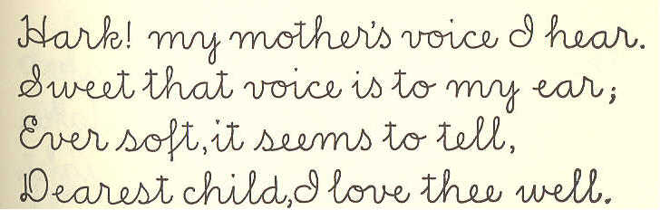

130 ECLECTIC SERIES.

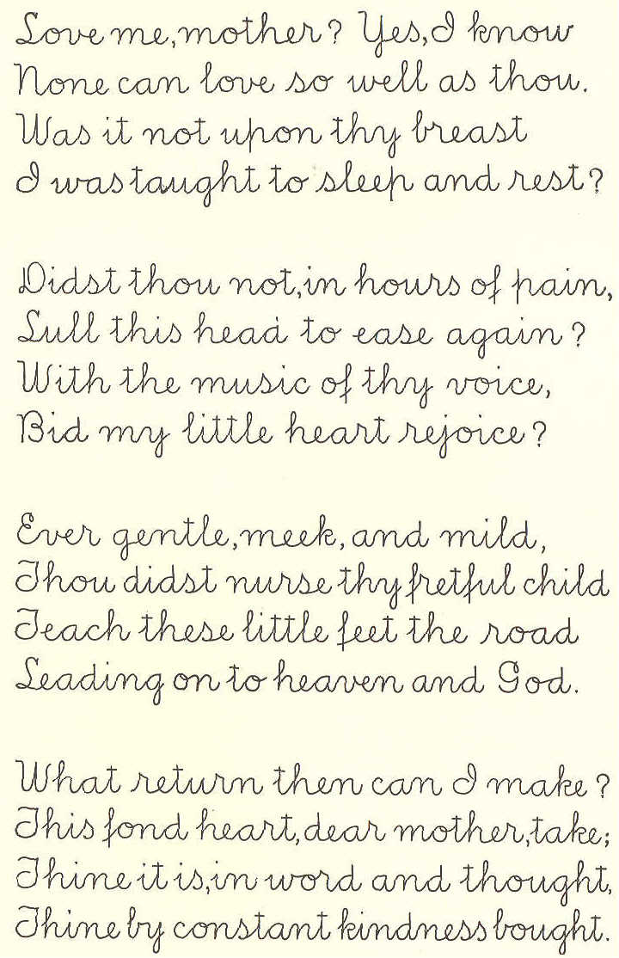
Love me, mother? Yes, I know
None can love so well as thou.
Was it not upon thy breast
I was taught to sleep and rest?

Didst thou not, in hours of pain,
Lull this head to ease again?
With the music of thy voice,
Bid my little heart rejoice?

Ever gentle, meek and mild,
Thou didst nurse thy fretful child.
Teach these little feet the road
Leading on to heaven and God.

What return then can I make?
This fond heart, dear mother take;
Thine its, in word and thought,
Thine by constant kindness bought.

SECOND READER. 131

LESSON LX.
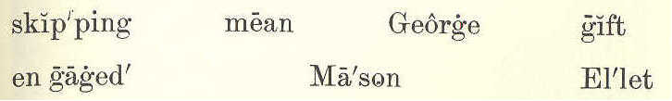
skip'ping mean George gift
en gaged' Mason El'let

THE BROKEN WINDOW.

1. George Ellet had a bright silver dollar for a New-year gift.
2. He thought of all the fine things he might buy with it.
3. The ground was all covered with snow; but the sun shone out bright, and everything looked beautiful.
4. So George put on his hat, and ran into the street. As he went skipping along, he met some boys throwing snowballs. George soon engaged in the sport.
5. He sent a ball at James Mason, but it missed him, and broke a window on the other side of the street.
6. George feared some one would come out of the house and find him. So he ran off as fast as he could.
132 ECLECTIC SERIES.

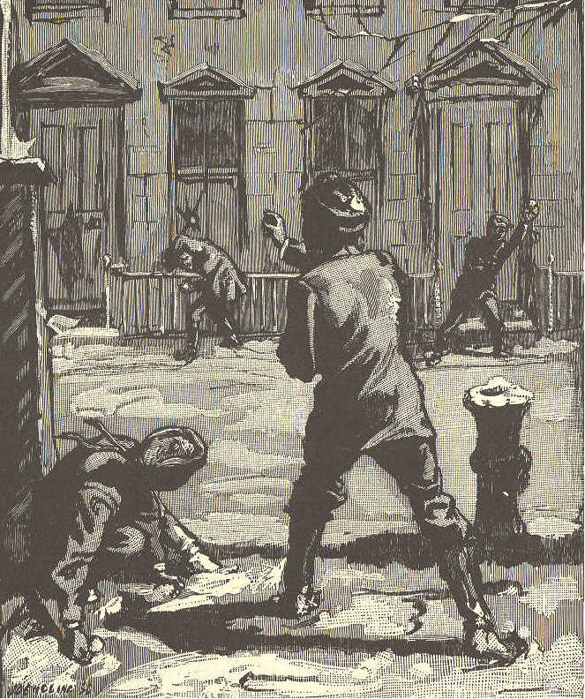

7. As soon as he got round the next corner, George stopped, because he was very sorry for what he had done.
8. He said to himself, "I have no right to spend my silver dollar, now. I ought to go back, and pay for the glass I broke with my snowball."
SECOND READER. 133

9. He went up and down the street, and felt very sad. He wished very much to buy something nice. He also wished to pay for the broken glass.
10. At last he said, "It was wrong to break the window, though I did not mean to do it. I will go and pay for it, if it takes all my money, I will try not to be sorry. I do not think the man will hurt me if I pay for the mischief I have done."

LESSON LXI.
mer'chant hon'est ly rang mind
part'ner with out' rich bell
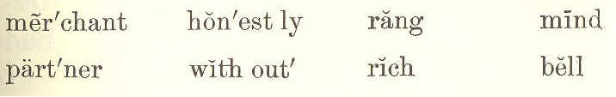

THE BROKEN WINDOW.
(CONCLUDED.)

1. George started off, and felt much happier for having made up his mind to do what was right.
2. He rang the doorbell. When the man came out, George said, "Sir, I
134 ECLECTIC SERIES.

threw a snowball through your window. But I did not intend to do it. I am very sorry, and wish to pay you. Here is the dollar my father gave me as a New-year gift."
3. The gentleman took the dollar, and asked George if he had no more money. George said he had not. "Well," said he, "this will do."
4. So, after asking George his name, and where he lived, he called him an honest boy, and shut the door.
5. George went home at dinner time, with a face as rosy, and eyes as bright, as if nothing had gone wrong. At dinner, Mr. Ellet asked him what he had bought with his money.
6. George very honestly told him all about the broken window, and said he felt very well without any money to spend.
7. When dinner was over, Mr. Ellet told George to go and look in his cap. He did so, and found two silver dollars there.
SECOND READER. 135

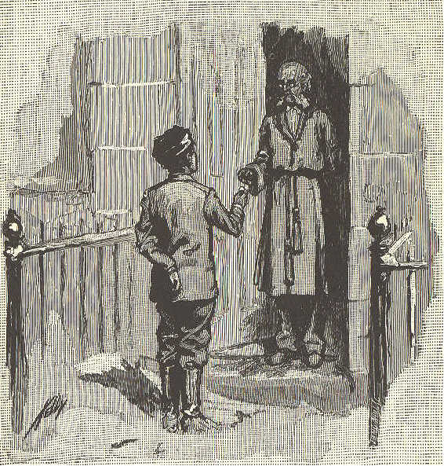

8. The man, whose window had been broken, had been there, and told Mr. Ellet about it. He gave back George's dollar and another besides.
9. A short time after this, the man came and told Mr. Ellet that he wanted a good boy to stay in his store.
10. As soon as George left school, he went to live with this man, who was a rich merchant. In a few years he became the merchant's partner.
136 ECLECTIC SERIES.

LESSON LXII.
line fig'ure sec'ond per'fect ly
grain verse ad vice' im pa'tient
stud'y bus'i ly fol'lowed un der stand'
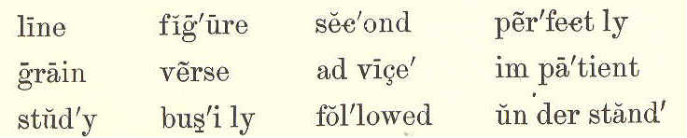

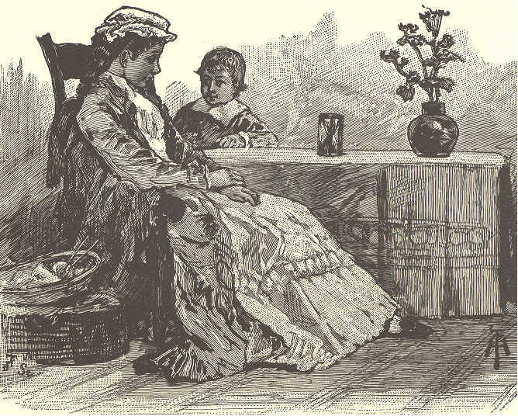

FRANK AND THE HOURGLASS.

1. Frank was a very talkative little boy. He never saw a new thing without asking a great many questions about it.
2. His mother was very patient and
SECOND READER. 137

kind. When it was proper to answer his questions, she would do so.
3. Sometimes she would say, "You are not old enough to understand that, my son. When you are ten years old, you may ask me about it, and I will tell you."
4. When his mother said this, he never teased any more. He knew she always liked to answer him when he asked proper questions.
5. The first time Frank saw an hourglass, he was very much amused; but he did not know what it was.
6. His mother said, "An hourglass is made in the shape of the figure 8. The sand is put in at one end, and runs through a small hole in the middle. As much sand is put into the glass as will run through in an hour."
7. Frank watched the little stream of sand. He was impatient, because it would not run faster. "Let me shake it, mother," said he; "it is lazy, and will never get through."
138 ECLECTIC SERIES.

8. "Oh yes, it will, my son," said his mother, "The sand moves by little and little, but it moves all the time.
9. "When you look at the hands of the clock, you think they go very slowly, and so they do; but they never stop.
10, "While you are at play the sand is running, grain by grain, The hands of the clock are moving, second by second.
11. "At night, the sand in the hourglass has run through twelve times. The hour hand of the clock has moved all around its great face.
12. "This because they keep work every minute. They do not stop to think how much they have to do, and how long it will take them to do it."
13. Now, Frank's mother wanted him to learn a little hymn; but he said "Mother, I can never learn it."
14. His mother said, "Study all the time. Never stop to ask how long it
SECOND READER. 139
will take to learn it. You will be able to say it very soon."
15. Frank followed his mother's advice. He studied line after line, very busily; and in one hour and a half he knew the hymn perfectly.

LESSON LXIII.

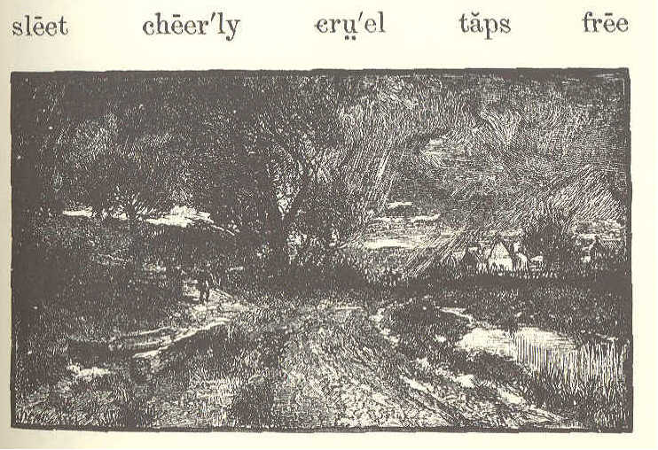
sleet cheer'ly cru'el taps free

MARCH.

1. In the snowing and the blowing,
In the cruel sleet,
Little flowers begin their growing
Far beneath our feet.
140 ECLECTIC SERIES.

2. Softly taps the Spring, and cheerly,--
"Darlings, are you here?"
Till they answer, "We are nearly,
Nearly ready, dear."

3. "Where is Winter, with his snowing?
Tell us, Spring," they say.
Then she answers, "He is going,
Going on his way.

4. "Poor old Winter does not love you;
But his time is past;
Soon my birds shall sing above you;--
Set you free at last."
Mary Mapes Dodge.

LESSON LXIV.
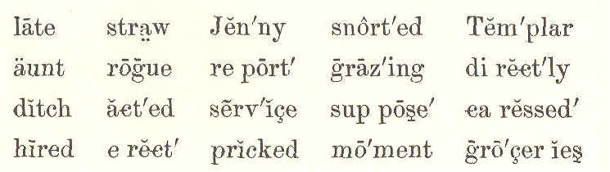
late straw Jen'ny snort'ed Tem'plar
aunt rogue re port' graz'ing di rect'ly
ditch act'ed ser'vice sup pose' ca ressed'
hired e rect' pricked mo'ment gro'cer ies

JENNY'S CALL.

1. "It's of no use, Mrs. Templar; I have been trying the greater part of an hour
SECOND READER. 141

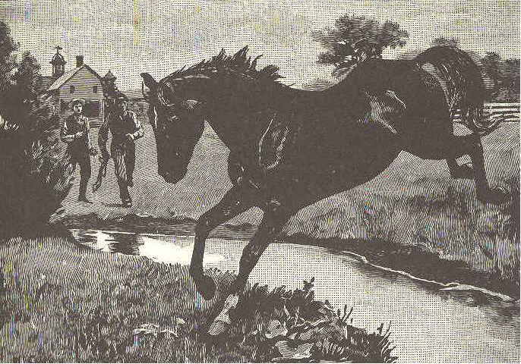

to catch that rogue of a horse. She won't be caught."
2. Such was the report the hired man brought in to Mrs. Templar one pleasant May morning, when she had been planning a ride.
3. "I suppose it can not be helped, but I wanted her very much," she said, as she turned away.
4. "What was it you wanted, mother?" asked Jenny Templar, a bright, brown-haired, brown-eyed girl of twelve, who had just come into the room.
142 ECLECTIC SERIES.

5. "Fanny," said the mother. "It is such a beautiful morning, I meant to drive down to the village, get some groceries, then call for your Aunt Ann, have a nice ride up the river road, and bring her home to dinner.
6. "But father is away for all day, and the men have been trying nearly an hour to catch Fanny; one of the men says she can't be caught."
7. "Maybe she can't by him," said Jenny, with a merry laugh. "But, get ready, mother; you shall go if you like. I'll catch Fanny, and harness her, too."
8. "Why, my child, they say she jumped the ditch three or four times, and acted like a wild creature. You'll only be late at school, and tire yourself for nothing."
9. "It won't take me long, mother. Fanny will come to me," said Jenny, cheerily. She put on her wide straw hat, and was off in a moment, down the hill, to the field where the horse was grazing.
SECOND READER. 143

10. The moment Fanny heard the rustle of Jenny's dress, she pricked up her ears, snorted, and, with head erect, seemed ready to bound away again.

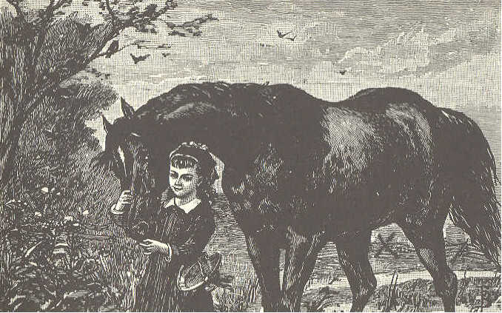

11. "Fanny! O Fanny!" called Jenny, and the beautiful creature turned her head. That gentle tone she well knew, and, glad to see her friend, she carne directly to the fence, and rubbed her head on the girl's shoulder. As soon as the gate was opened, she followed Jenny to the barn.
12. The men had treated her roughly, and she remembered it. But she knew
144 ECLECTIC SERIES.

and loved the voice that was always kind, and the hand that often fed and caressed her. She gave love for love, and willing service for kindness.

LESSON LXV.
rung Da'vy vi'o let re cess' ar range'
ferns ma'ple dain'ty lin'gered pret'ti est
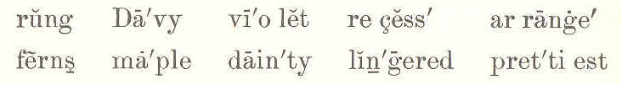

POOR DAVY.

1. It was recess time at the village school. The bell had rung, and the children had run out into the bright sunshine, wild with laughter and fun.
2. All but poor Davy. He came out last and very slowly, but he did not laugh. He was in trouble, and the bright, golden sunlight did not make him glad.
3. He walked across the yard, and sat down on a stone behind the old maple. A little bird on the highest branch sang just to make him laugh.
SECOND READER. 145

4. But Davy did not notice it. He was thinking of the cruel words that had been said about his ragged clothes. The tears stole out of his eyes, and ran down his cheeks.

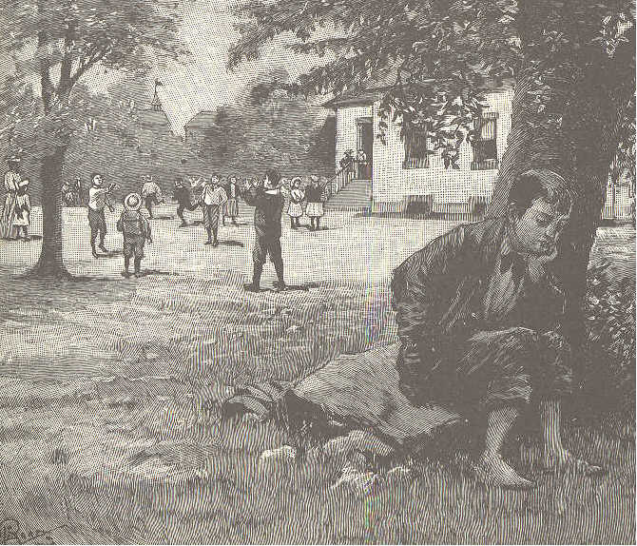

5. Poor Davy had no father, and his mother had to work hard to keep him at school.
6. That night, he went home by the path that led across the fields and through the woods. He still felt sad.
146 ECLECTIC SERIES.

7. Davy did not wish to trouble his mother; so he lingered a while among the trees, and at last threw himself on the green moss under them.
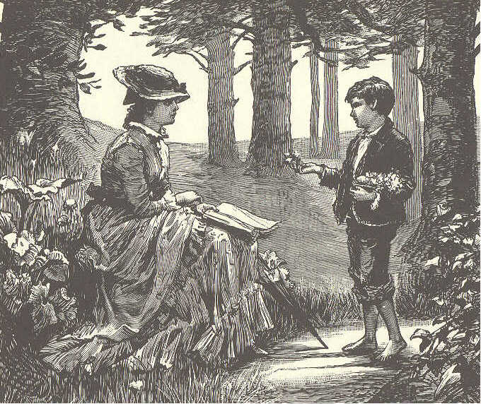
8. Just then his teacher came along. She saw who it was, and stopped, saying kindly, "What is the matter, Davy?"
9. He did not speak, but the tears began again to start.
10. "Won't you tell me? Perhaps I can help you."
SECOND READER. 147

11. Then he told her all his trouble. When he ended, she said, cheerily, "I have a plan, Davy, that I think will help you."
12. "Oh, what is it?" he said, sitting up with a look of hope, while a tear fell upon a blue violet.
l3. "Well, how would you like to be a little flower merchant?"
14. "And earn money?" said Davy. "That would be jolly. But where shall I get my flowers?"
15. "Right in these woods, and in the fields," said his teacher. " Here are lovely blue violets, down by the brook are white ones, and among the rocks are ferns and mosses. Bring them all to my house, and I will help you arrange them."
16. So, day after day, Davy hunted the woods for the prettiest flowers, and the most dainty ferns and mosses. After his teacher had helped to arrange them, he took them to the city that was near, and sold them.
148 ECLECTIC SERIES.

17. He soon earned money enough to buy new clothes. Now the sunshine and the bird's songs make him glad.

LESSON LXVI.
deep flour dough mill'er wheth'er
cook a far' dust'y cra'dles grind'ing
glow doth val'ley reap'ers a-knead'ing
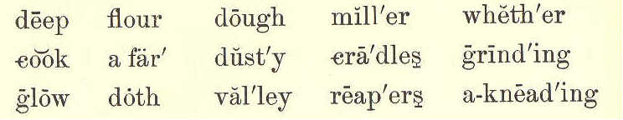

ALICE'S SUPPER.
1.
Far down in the valley the wheat grows deep,
And the reapers are making the cradles sweep;
And this is the song that I hear them sing,
While cheery and loud their voices ring:
"'Tis the finest wheat that ever did grow!
And it is for Alice's supper--ho! ho!"

2.
Far down by the river the old mill stands,
And the miller is rubbing his dusty hands;
And these are the words of the miller's lay,
As he watches the millstones grinding away:
"'Tis the finest flour that money can buy,
And it is for Alice's supper--hi! hi!"
SECOND READER. 149

3.
Downstairs in the kitchen the fire doth glow,
And cook is a-kneading the soft, white dough;
And this is the song she is singing to-day,
As merry and busy she's working away:
"'Tis the finest dough, whether near or afar,
And it is for Alice's supper--ha! ha!"

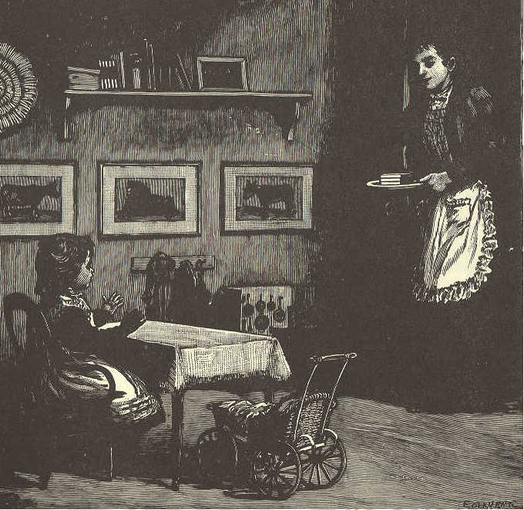

4.
To the nursery now comes mother, at last,
And what in her hand is she bringing so fast?
150 ECLECTIC SERIES.

'Tis a plateful of something, all yellow and white,
And she sings as she comes, with her smile so
bright:
"'Tis the best bread and butter I ever did see,
And it is for Alice's supper--he! he!"

LESSON LXVII.
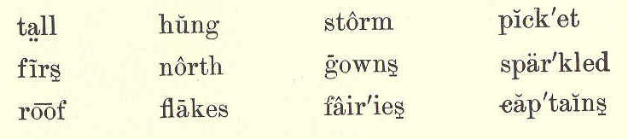
tall hung storm pick'et
firs north gowns spar'ked
roof flakes fair'ies cap'tains

A SNOWSTORM.

1. Last night, the cold north wind blew great snow clouds over the sky. Not a star, not a bit of blue sky could be seen.
2. Soon the tiny flakes floated softly down, like flocks of little white birds. Faster and faster they came, till they filled the air. They made no noise, but they were busy all night long.
3. They covered all the ground with a soft, white carpet. They hung beautiful
SECOND READER. 151

plumes on the tall, green firs. The little bushes, they put to sleep in warm nightgowns and caps.

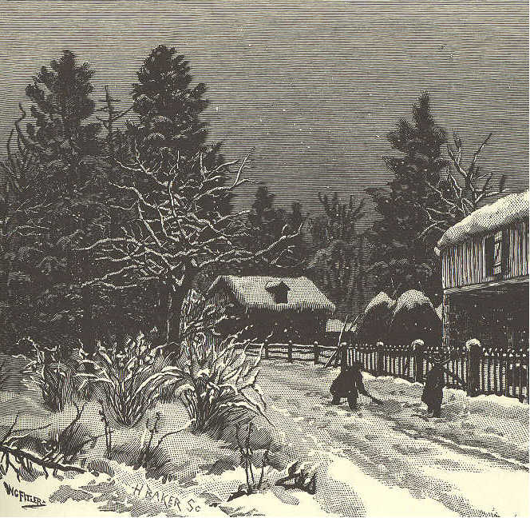

4. They hid the paths so that the boys might have the fun of digging new ones. They turned the old picket fence into a row of soldiers, and the gate posts into captains, with tall white hats on.
152 ECLECTIC SERIES.

5. The old corn basket that was left out by the barn, upside down, they made into a cunning little snow house with a round roof.
6. When the busy little flakes had done their work, the sun came up to see what they had been about.
7. He must have been pleased with what he saw, for he smiled such a bright, sweet smile, that the whole white world sparkled as if it were made of little stars.
8. Who would have thought that the black clouds could hide the little fairies that made the earth so beautiful!

LESSON LXVIII.

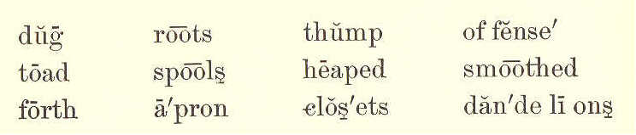
dug roots thump of fense'
toad spool heaped smoothed
forth a'pron clos'ets dan'de li ons

BESSIE.

1. One day, Bessie thought how nice it would be to have a garden with only
SECOND READER. 153

wild flowers in it. So into the house she ran to find her Aunt Annie, and ask her leave to go over on the shady hillside, across the brook, where the wild flowers grew thickest.

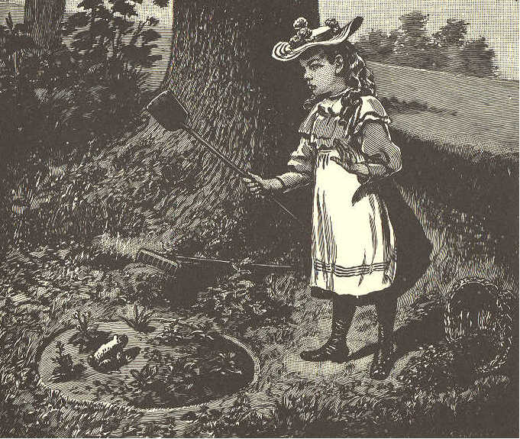

2. " Yes, indeed, you may go," said Aunt Annie; "but what will you put the roots and earth in while you are making the garden?"
3. "Oh," said Bessie, "I can take my apron."
154 ECLECTIC SERIES.

4. Her aunt laughed, and said, "A basket will be better, I think." So they looked in the closets and the attic, everywhere; but some of the baskets were full, and some broken; not one could they find that would do.
5. Then Aunt Annie turned out the spools and the bags from a nice large workbasket, and gave that to Bessie. "You may have this for your own," she said, "to fill with earth, or flowers, or anything you like."
6. "Oh I thank you," said Bessie, and she danced away through the garden. She slipped through the gate, out into the field all starred with dandelions, down in the hollow by the brook, then up on the hillside out of sight among the shady trees.
7. How she worked that afternoon! She heaped up the dark, rich earth, and smoothed it over with her hands. Then she dug up violets, and spring-beauties, and other flowers,--running back and forth, singing all the while.
SECOND READER. 155

8. The squirrels peeped out of their holes at Bessie. The birds sang in the branches overhead. Thump, came something all at once into the middle of the bed. Bessie jumped and upset the basket, and away it rolled down the hill.
9. How Bessie laughed when she saw a big, brown toad winking his bright eyes at her, as if he would say, "No offense, I hope."
10. Just then Bessie heard a bell ringing loudly. She knew it was calling her home; but how could she leave her basket? She must look for that first.
11. "Waiting, waiting, waiting," all at once sang a bird out of sight among the branches; "waiting, Bessie."
12. "Sure enough," said Bessie; "perhaps I'm making dear mother or auntie wait; and they are so good to me. I'd better let the basket wait. Take care of it, birdie; and don't jump on my flowers, Mr. Toad."
156 ECLECTIC SERIES.

LESSON LXIX.
visit soaked o be'di ent ru'ined

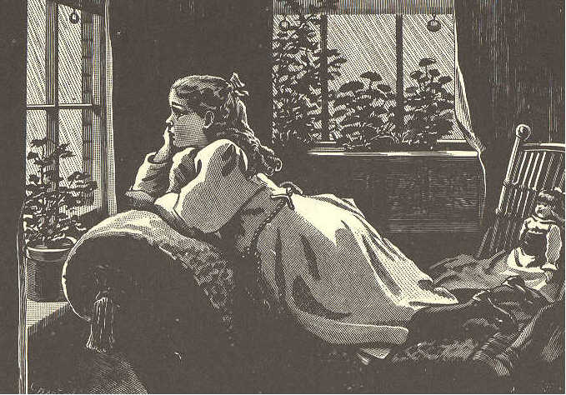

BESSIE.
(CONCLUDED.)

1. She was back at the house in a few minutes, calling, "Mother! mother! auntie! Who wants me?"
2. "I, dear," said her mother. "I am going away for a long visit, and if you had not come at once, I could not have said good-by to my little girl."
SECOND READER 157

3. Then Bessie's mother kissed her, and told her to obey her kind aunt while she was gone.
4. The next morning, Bessie waked to find it raining hard. She went into her aunt's room with a very sad face. "O auntie! this old rain!"
5, "This new, fresh, beautiful rain, Bessie! How it will make our flowers grow, and what a good time we can have together in the house!"
6. "I know it, auntie; but you will think me so careless!"
- "To let it rain?"
8. "No; don't laugh, Aunt Annie; to leave your nice basket out of doors all night; and now it will be soaked and ruined in this--this--beautiful rain." Bessie did not look as if the beautiful rain made her very happy.
9. "You must be more careful, dear, another time," said her aunt, gently. "But come, tell me all about it."
10. So Bessie crept very close to her auntie's side, and told her of her happy
158 ECLECTIC SERIES.

time the day before; of the squirrel, and the toad, and how the basket rolled away down the hill; and then how the bell rang, and she could not stop to find the basket.
11. "And you did quite right," said her aunt. "If you had stopped, your mother must have waited a whole day, or else gone without seeing you. When I write, I will tell her how obedient you were, and that will please her more than anything else I can say."

LESSON LXX.
sought sure'ly (shu) wel'come light'some
loft'y maid'en cher'ished in tro duce'
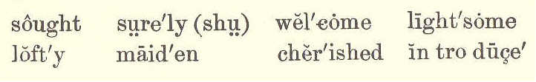

CHEERFULNESS.

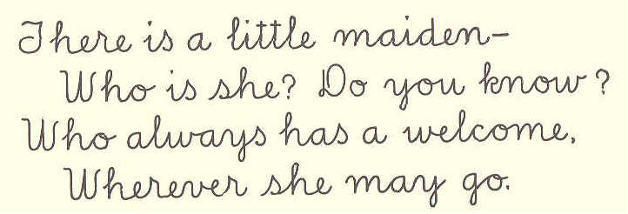
There is a little maiden--
Who is she? Do you know?
Who always has a welcome,
Wherever she may go.

SECOND READER. 159

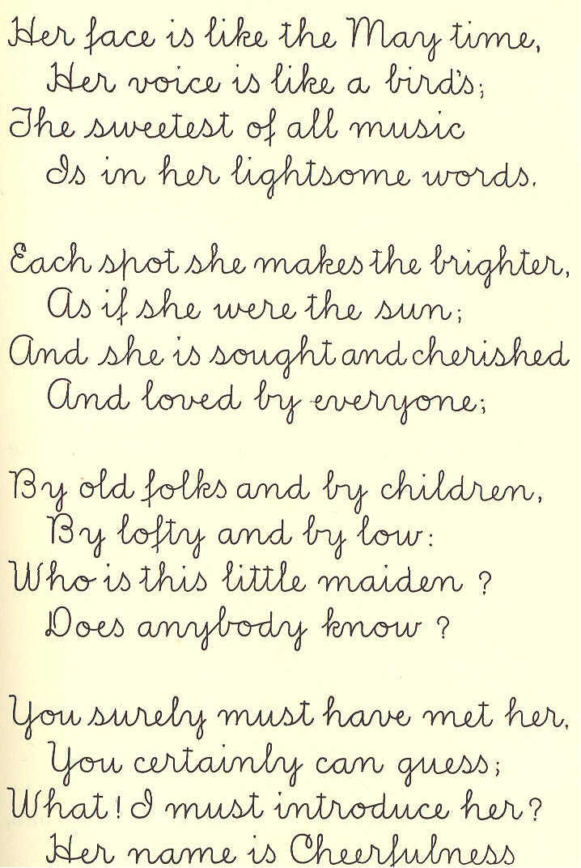
Her face is like the May time,
Her voice is like the bird's;
The sweetest of all music
Is in her lightsome words.

Each spot she makes the brighter,
As if she were the sun;
And she is sought and cherished
And loved by everyone;

By old folks and by children,
By loft and by low;
Who is this little maiden?
Does anybody know?

You surely must have met her.
You certainly can guess;
What! I must introduce her?
Her name is Cheeerfulness.
Marian Douglas

Marian Douglas.
160 SECOND READER.

LESSON LXXI.

west'ern breathe dy'ing moon babe sails

LULLABY.

1. Sweet and low, sweet and low,
Wind of the western sea,
Low, low, breathe and blow,
Wind of the western sea!
Over the rolling waters go,
Come from the dying moon, and blow,
Blow him again to me;
While my little one, while my pretty one
sleeps.

2. Sleep and rest, sleep and rest,
Father will come to thee soon;
Rest, rest, on mother's breast,
Father will come to thee soon;
Father will come to his babe in the nest,
Silver sails all out of the west,
Under the silver moon;
Sleep, my little one, sleep, my pretty one,
sleep.
Tennyson.


End of the Project Gutenberg EBook of McGuffey's Second Eclectic Reader
by William Holmes McGuffey

*** END OF THIS PROJECT GUTENBERG EBOOK MCGUFFEY'S SECOND ECLECTIC READER ***

***** This file should be named 14668-doc.doc or 14668-doc.zip *****
This and all associated files of various formats will be found in:
http://www.gutenberg.org/1/4/6/6/14668/

Produced by Don Kostuch

Updated editions will replace the previous one--the old editions
will be renamed.

Creating the works from public domain print editions means that no
one owns a United States copyright in these works, so the Foundation
(and you!) can copy and distribute it in the United States without
permission and without paying copyright royalties. Special rules,
set forth in the General Terms of Use part of this license, apply to
copying and distributing Project Gutenberg-tm electronic works to
protect the PROJECT GUTENBERG-tm concept and trademark. Project
Gutenberg is a registered trademark, and may not be used if you
charge for the eBooks, unless you receive specific permission. If you
do not charge anything for copies of this eBook, complying with the
rules is very easy. You may use this eBook for nearly any purpose
such as creation of derivative works, reports, performances and
research. They may be modified and printed and given away--you may do
practically ANYTHING with public domain eBooks. Redistribution is
subject to the trademark license, especially commercial
redistribution.

*** START: FULL LICENSE ***

THE FULL PROJECT GUTENBERG LICENSE
PLEASE READ THIS BEFORE YOU DISTRIBUTE OR USE THIS WORK

To protect the Project Gutenberg-tm mission of promoting the free
distribution of electronic works, by using or distributing this work
(or any other work associated in any way with the phrase "Project
Gutenberg"), you agree to comply with all the terms of the Full Project
Gutenberg-tm License (available with this file or online at
http://gutenberg.net/license).

Section 1. General Terms of Use and Redistributing Project Gutenberg-tm
electronic works

1.A. By reading or using any part of this Project Gutenberg-tm
electronic work, you indicate that you have read, understand, agree to
and accept all the terms of this license and intellectual property
(trademark/copyright) agreement. If you do not agree to abide by all
the terms of this agreement, you must cease using and return or destroy
all copies of Project Gutenberg-tm electronic works in your possession.
If you paid a fee for obtaining a copy of or access to a Project
Gutenberg-tm electronic work and you do not agree to be bound by the
terms of this agreement, you may obtain a refund from the person or
entity to whom you paid the fee as set forth in paragraph 1.E.8.

1.B. "Project Gutenberg" is a registered trademark. It may only be
used on or associated in any way with an electronic work by people who
agree to be bound by the terms of this agreement. There are a few
things that you can do with most Project Gutenberg-tm electronic works
even without complying with the full terms of this agreement. See
paragraph 1.C below. There are a lot of things you can do with Project
Gutenberg-tm electronic works if you follow the terms of this agreement
and help preserve free future access to Project Gutenberg-tm electronic
works. See paragraph 1.E below.

1.C. The Project Gutenberg Literary Archive Foundation ("the Foundation"
or PGLAF), owns a compilation copyright in the collection of Project
Gutenberg-tm electronic works. Nearly all the individual works in the
collection are in the public domain in the United States. If an
individual work is in the public domain in the United States and you are
located in the United States, we do not claim a right to prevent you from
copying, distributing, performing, displaying or creating derivative
works based on the work as long as all references to Project Gutenberg
are removed. Of course, we hope that you will support the Project
Gutenberg-tm mission of promoting free access to electronic works by
freely sharing Project Gutenberg-tm works in compliance with the terms of
this agreement for keeping the Project Gutenberg-tm name associated with
the work. You can easily comply with the terms of this agreement by
keeping this work in the same format with its attached full Project
Gutenberg-tm License when you share it without charge with others.

1.D. The copyright laws of the place where you are located also govern
what you can do with this work. Copyright laws in most countries are in
a constant state of change. If you are outside the United States, check
the laws of your country in addition to the terms of this agreement
before downloading, copying, displaying, performing, distributing or
creating derivative works based on this work or any other Project
Gutenberg-tm work. The Foundation makes no representations concerning
the copyright status of any work in any country outside the United
States.

1.E. Unless you have removed all references to Project Gutenberg:

1.E.1. The following sentence, with active links to, or other immediate
access to, the full Project Gutenberg-tm License must appear prominently
whenever any copy of a Project Gutenberg-tm work (any work on which the
phrase "Project Gutenberg" appears, or with which the phrase "Project
Gutenberg" is associated) is accessed, displayed, performed, viewed,
copied or distributed:

This eBook is for the use of anyone anywhere at no cost and with
almost no restrictions whatsoever. You may copy it, give it away or
re-use it under the terms of the Project Gutenberg License included
with this eBook or online at www.gutenberg.net

1.E.2. If an individual Project Gutenberg-tm electronic work is derived
from the public domain (does not contain a notice indicating that it is
posted with permission of the copyright holder), the work can be copied
and distributed to anyone in the United States without paying any fees
or charges. If you are redistributing or providing access to a work
with the phrase "Project Gutenberg" associated with or appearing on the
work, you must comply either with the requirements of paragraphs 1.E.1
through 1.E.7 or obtain permission for the use of the work and the
Project Gutenberg-tm trademark as set forth in paragraphs 1.E.8 or
1.E.9.

1.E.3. If an individual Project Gutenberg-tm electronic work is posted
with the permission of the copyright holder, your use and distribution
must comply with both paragraphs 1.E.1 through 1.E.7 and any additional
terms imposed by the copyright holder. Additional terms will be linked
to the Project Gutenberg-tm License for all works posted with the
permission of the copyright holder found at the beginning of this work.

1.E.4. Do not unlink or detach or remove the full Project Gutenberg-tm
License terms from this work, or any files containing a part of this
work or any other work associated with Project Gutenberg-tm.

1.E.5. Do not copy, display, perform, distribute or redistribute this
electronic work, or any part of this electronic work, without
prominently displaying the sentence set forth in paragraph 1.E.1 with
active links or immediate access to the full terms of the Project
Gutenberg-tm License.

1.E.6. You may convert to and distribute this work in any binary,
compressed, marked up, nonproprietary or proprietary form, including any
word processing or hypertext form. However, if you provide access to or
distribute copies of a Project Gutenberg-tm work in a format other than
"Plain Vanilla ASCII" or other format used in the official version
posted on the official Project Gutenberg-tm web site (www.gutenberg.net),
you must, at no additional cost, fee or expense to the user, provide a
copy, a means of exporting a copy, or a means of obtaining a copy upon
request, of the work in its original "Plain Vanilla ASCII" or other
form. Any alternate format must include the full Project Gutenberg-tm
License as specified in paragraph 1.E.1.

1.E.7. Do not charge a fee for access to, viewing, displaying,
performing, copying or distributing any Project Gutenberg-tm works
unless you comply with paragraph 1.E.8 or 1.E.9.

1.E.8. You may charge a reasonable fee for copies of or providing
access to or distributing Project Gutenberg-tm electronic works provided
that

- You pay a royalty fee of 20% of the gross profits you derive from
the use of Project Gutenberg-tm works calculated using the method
you already use to calculate your applicable taxes. The fee is
owed to the owner of the Project Gutenberg-tm trademark, but he
has agreed to donate royalties under this paragraph to the
Project Gutenberg Literary Archive Foundation. Royalty payments
must be paid within 60 days following each date on which you
prepare (or are legally required to prepare) your periodic tax
returns. Royalty payments should be clearly marked as such and
sent to the Project Gutenberg Literary Archive Foundation at the
address specified in Section 4, "Information about donations to
the Project Gutenberg Literary Archive Foundation."

- You provide a full refund of any money paid by a user who notifies
you in writing (or by e-mail) within 30 days of receipt that s/he
does not agree to the terms of the full Project Gutenberg-tm
License. You must require such a user to return or
destroy all copies of the works possessed in a physical medium
and discontinue all use of and all access to other copies of
Project Gutenberg-tm works.

- You provide, in accordance with paragraph 1.F.3, a full refund of any
money paid for a work or a replacement copy, if a defect in the
electronic work is discovered and reported to you within 90 days
of receipt of the work.

- You comply with all other terms of this agreement for free
distribution of Project Gutenberg-tm works.

1.E.9. If you wish to charge a fee or distribute a Project Gutenberg-tm
electronic work or group of works on different terms than are set
forth in this agreement, you must obtain permission in writing from
both the Project Gutenberg Literary Archive Foundation and Michael
Hart, the owner of the Project Gutenberg-tm trademark. Contact the
Foundation as set forth in Section 3 below.

1.F.

1.F.1. Project Gutenberg volunteers and employees expend considerable
effort to identify, do copyright research on, transcribe and proofread
public domain works in creating the Project Gutenberg-tm
collection. Despite these efforts, Project Gutenberg-tm electronic
works, and the medium on which they may be stored, may contain
"Defects," such as, but not limited to, incomplete, inaccurate or
corrupt data, transcription errors, a copyright or other intellectual
property infringement, a defective or damaged disk or other medium, a
computer virus, or computer codes that damage or cannot be read by
your equipment.

1.F.2. LIMITED WARRANTY, DISCLAIMER OF DAMAGES - Except for the "Right
of Replacement or Refund" described in paragraph 1.F.3, the Project
Gutenberg Literary Archive Foundation, the owner of the Project
Gutenberg-tm trademark, and any other party distributing a Project
Gutenberg-tm electronic work under this agreement, disclaim all
liability to you for damages, costs and expenses, including legal
fees. YOU AGREE THAT YOU HAVE NO REMEDIES FOR NEGLIGENCE, STRICT
LIABILITY, BREACH OF WARRANTY OR BREACH OF CONTRACT EXCEPT THOSE
PROVIDED IN PARAGRAPH F3. YOU AGREE THAT THE FOUNDATION, THE
TRADEMARK OWNER, AND ANY DISTRIBUTOR UNDER THIS AGREEMENT WILL NOT BE
LIABLE TO YOU FOR ACTUAL, DIRECT, INDIRECT, CONSEQUENTIAL, PUNITIVE OR
INCIDENTAL DAMAGES EVEN IF YOU GIVE NOTICE OF THE POSSIBILITY OF SUCH
DAMAGE.

1.F.3. LIMITED RIGHT OF REPLACEMENT OR REFUND - If you discover a
defect in this electronic work within 90 days of receiving it, you can
receive a refund of the money (if any) you paid for it by sending a
written explanation to the person you received the work from. If you
received the work on a physical medium, you must return the medium with
your written explanation. The person or entity that provided you with
the defective work may elect to provide a replacement copy in lieu of a
refund. If you received the work electronically, the person or entity
providing it to you may choose to give you a second opportunity to
receive the work electronically in lieu of a refund. If the second copy
is also defective, you may demand a refund in writing without further
opportunities to fix the problem.

1.F.4. Except for the limited right of replacement or refund set forth
in paragraph 1.F.3, this work is provided to you 'AS-IS' WITH NO OTHER
WARRANTIES OF ANY KIND, EXPRESS OR IMPLIED, INCLUDING BUT NOT LIMITED TO
WARRANTIES OF MERCHANTIBILITY OR FITNESS FOR ANY PURPOSE.

1.F.5. Some states do not allow disclaimers of certain implied
warranties or the exclusion or limitation of certain types of damages.
If any disclaimer or limitation set forth in this agreement violates the
law of the state applicable to this agreement, the agreement shall be
interpreted to make the maximum disclaimer or limitation permitted by
the applicable state law. The invalidity or unenforceability of any
provision of this agreement shall not void the remaining provisions.

1.F.6. INDEMNITY - You agree to indemnify and hold the Foundation, the
trademark owner, any agent or employee of the Foundation, anyone
providing copies of Project Gutenberg-tm electronic works in accordance
with this agreement, and any volunteers associated with the production,
promotion and distribution of Project Gutenberg-tm electronic works,
harmless from all liability, costs and expenses, including legal fees,
that arise directly or indirectly from any of the following which you do
or cause to occur: (a) distribution of this or any Project Gutenberg-tm
work, (b) alteration, modification, or additions or deletions to any
Project Gutenberg-tm work, and (c) any Defect you cause.

Section 2. Information about the Mission of Project Gutenberg-tm

Project Gutenberg-tm is synonymous with the free distribution of
electronic works in formats readable by the widest variety of computers
including obsolete, old, middle-aged and new computers. It exists
because of the efforts of hundreds of volunteers and donations from
people in all walks of life.

Volunteers and financial support to provide volunteers with the
assistance they need, is critical to reaching Project Gutenberg-tm's
goals and ensuring that the Project Gutenberg-tm collection will
remain freely available for generations to come. In 2001, the Project
Gutenberg Literary Archive Foundation was created to provide a secure
and permanent future for Project Gutenberg-tm and future generations.
To learn more about the Project Gutenberg Literary Archive Foundation
and how your efforts and donations can help, see Sections 3 and 4
and the Foundation web page at http://www.pglaf.org.

Section 3. Information about the Project Gutenberg Literary Archive
Foundation

The Project Gutenberg Literary Archive Foundation is a non profit
501(c)(3) educational corporation organized under the laws of the
state of Mississippi and granted tax exempt status by the Internal
Revenue Service. The Foundation's EIN or federal tax identification
number is 64-6221541. Its 501(c)(3) letter is posted at
http://pglaf.org/fundraising. Contributions to the Project Gutenberg
Literary Archive Foundation are tax deductible to the full extent
permitted by U.S. federal laws and your state's laws.

The Foundation's principal office is located at 4557 Melan Dr. S.
Fairbanks, AK, 99712., but its volunteers and employees are scattered
throughout numerous locations. Its business office is located at
809 North 1500 West, Salt Lake City, UT 84116, (801) 596-1887, email
business@pglaf.org. Email contact links and up to date contact
information can be found at the Foundation's web site and official
page at http://pglaf.org

For additional contact information:
Dr. Gregory B. Newby
Chief Executive and Director
gbnewby@pglaf.org

Section 4. Information about Donations to the Project Gutenberg
Literary Archive Foundation

Project Gutenberg-tm depends upon and cannot survive without wide
spread public support and donations to carry out its mission of
increasing the number of public domain and licensed works that can be
freely distributed in machine readable form accessible by the widest
array of equipment including outdated equipment. Many small donations
($1 to $5,000) are particularly important to maintaining tax exempt
status with the IRS.

The Foundation is committed to complying with the laws regulating
charities and charitable donations in all 50 states of the United
States. Compliance requirements are not uniform and it takes a
considerable effort, much paperwork and many fees to meet and keep up
with these requirements. We do not solicit donations in locations
where we have not received written confirmation of compliance. To
SEND DONATIONS or determine the status of compliance for any
particular state visit http://pglaf.org

While we cannot and do not solicit contributions from states where we
have not met the solicitation requirements, we know of no prohibition
against accepting unsolicited donations from donors in such states who
approach us with offers to donate.

International donations are gratefully accepted, but we cannot make
any statements concerning tax treatment of donations received from
outside the United States. U.S. laws alone swamp our small staff.

Please check the Project Gutenberg Web pages for current donation
methods and addresses. Donations are accepted in a number of other
ways including including checks, online payments and credit card
donations. To donate, please visit: http://pglaf.org/donate

Section 5. General Information About Project Gutenberg-tm electronic
works.

Professor Michael S. Hart is the originator of the Project Gutenberg-tm
concept of a library of electronic works that could be freely shared
with anyone. For thirty years, he produced and distributed Project
Gutenberg-tm eBooks with only a loose network of volunteer support.

Project Gutenberg-tm eBooks are often created from several printed
editions, all of which are confirmed as Public Domain in the U.S.
unless a copyright notice is included. Thus, we do not necessarily
keep eBooks in compliance with any particular paper edition.

Most people start at our Web site which has the main PG search facility:

http://www.gutenberg.net

This Web site includes information about Project Gutenberg-tm,
including how to make donations to the Project Gutenberg Literary
Archive Foundation, how to help produce our new eBooks, and how to
subscribe to our email newsletter to hear about new eBooks.

